**GOVERNMENT OF MAHARASHTRA**

DIRECTORATE OF VOCATIONAL EDUCATION & TRAINING

**GOVERNMENT INDUSTRIAL TRAINING INSTITUTE (WOMEN), NAGPUR DIST. NAGPUR**

**INSTITUTE STRATEGIC PLAN (ISP)**

**Principal,**

**Government Industrial Training Institute,**

**(Women), Nagpur Dist. Nagpur**

[**Email-iti.nagpurg@dvet.gov.in**](mailto:Email-iti.nagpurg@dvet.gov.in)**,** [**pitigirlsnagpur@yahoo.com**](mailto:pitigirlsnagpur@yahoo.com)

**Ph. No. 0712-2557050**

**Annexure 7: Format for Institute Strategic Plan**

**Institute Strategic Plan (ISP)**

**Part A: Institutional Details**

1. **Information about ITI**

|  |  |  |
| --- | --- | --- |
| **Sr. No** | **Information** | **Details** |
| 1 | ITI Code as per NCVT MIS portal | GU27000151 |
| 2 | ITI Name and Address | Govt. Industrial Training Institute (Woman), Nagpur- Malviya Road, Sitaburdi, Nagpur - 440012 |
| 3 | State/UT | Maharashtra |
| 4 | Details of Principal |  |
| Name | S.N.Darunde |
| Phone | 7122557050 |
| Email | iti.nagpurg@dvet.gov.in |
| Date of Appointment | 12.08.2016 |
| 5 | Is the Principal Full-time ? | Yes |
| 6 | Year of Establishment of the  ITI | 1985 |
| 7 | Affiliation Number given by  DGT | DGET-12(3)94 –TC dt.20-06-1994  DGET-12/01/1998-TC dt. 01-07-1998  DGET-12/01/2012-TC dt.27-04-2012  DGET-12/01/2011-TC dt.29-04-2011  DGET-12/09/1998-TC dt.01-07-1998  DGET-6(11) 87 TC dt. 10-07-1987  DGET-6(11) 86 TC dt.05-09-1986  DGET-12/01/2004-TC dt.30-06-2004 |
| 8 | Validity of affiliation till | Year 2099 |
| 9 | Grading given by Core Grading Committee | 2.16 |
| 10 | Has the ITI received supportunder:   1. Vocational Training Improvement Project 2. Upgrading of 1396 Government ITI in PPP mode 3. Model ITI Scheme 4. Any Other Scheme | If Yes, Utilization % as on date  include   1. Yes(World bank assistedproject)Release amount -292.09 lac utilization 100% 2. No 3. No 4. NO |
| 11 | Revenue Generation | |
|  | 1. Does the ITI engage in any revenue generation activities? Provide details. | NO |
|  | 1. If yes, revenue generated during:   2015-16  2016-17  2017-18 | NIL |

1. **Enrolments, pass out and diversity**

(a) Enrolments, pass out and diversity data Summary

(Summary of all CTS trade or any other NSQF compliant trade offered in the ITI with a minimum duration of 300 hours.)

|  |  |
| --- | --- |
| **Field** | **Value**  As mentioned in the NCVT MIS Portal  (For the academic session 2017-18) |
| 1. % ratio of number of trainee appearing in examination to total trainee enrolment | 87%(360/406) |
| 1. Pass-out Rate   (Proportion of students who passed in first attempt as a percent of total hall tickets issued) | 77% (278/360) |
| 1. Proportion of Female trainees | 100% |

(b) Please provide details of existing CTS Trades (For the academic session 2017-18)

|  |  |  |  |  |  |  |  |  |  |  |  |  |  |  |
| --- | --- | --- | --- | --- | --- | --- | --- | --- | --- | --- | --- | --- | --- | --- |
| **Details of Available CTS Trades** | | | **Trainees on roll** | | | | | | | | | | | |
| Trade Name | Sanctioned units | Seating Capacity | Up to 6 Month course | 1 Year course | | | | | 2 year Course | | | | | Total Trainees |
|  |  |  |  | F | SC | ST | OTHERS | TOTAL | F | SC | ST | OTHERS | TOTAL |  |
| 1.Basic Cosmetology | 2 | 52 | NIL | 52 | 15 | 3 | 34 | 52 |  |  |  |  |  | 52 |
| 2.Computer Hardware & Network Maintenance | 1 | 26 | 26 | 13 | 1 | 12 | 26 |  |  |  |  |  | 26 |
| 3.Computer Operator and Programming Assistant | 2 | 52 | 52 | 20 | 5 | 27 | 52 |  |  |  |  |  | 52 |
| 4.Draughtsman (Civil) | 2 | 52 |  |  |  |  |  | 26 | 11 | 2 | 13 | 26 | 26 |
| 5.Dress Making | 1 | 21 | 21 | 3 | 1 | 17 | 21 |  |  |  |  |  | 21 |
| 6.Electrician | 2 | 42 |  |  |  |  |  | Admitted in 2016-18 | | | | | |
| 7.Electronics Mechanic | 2 | 52 |  |  |  |  |  | 26 | 12 | 3 | 11 | 26 | 26 |
| 8.Fruit and Vegetable Processor | 1 | 26 | 26 | 9 | 1 | 16 | 26 |  |  |  |  |  | 26 |
| 9.Information & Communication Technology System Maintenance | 2 | 52 |  |  |  |  |  | 26 | 13 | - | 13 | 26 | 26 |
| 10.Mechanic Consumer Electronics Appliances | 1 | 26 |  |  |  |  |  | 26 | 12 | - | 14 | 26 | 26 |
| 11.Secretarial Practice (English) | 1 | 26 | 26 | 11 | 1 | 14 | 26 |  |  |  |  |  | 26 |
| 12.Multimedia Animation | 2 | 52 | Yet not started | | | | |  |  |  |  |  | - |

(c) Please provide details of any other NSQF compliant trade offered in ITI with a minimum duration of 300 hours ( For the academic session 2017-18)

|  |  |  |  |  |  |  |  |  |  |  |
| --- | --- | --- | --- | --- | --- | --- | --- | --- | --- | --- |
| Trade Name | Duration | Dates of current/ most recent batch | Affiliation/ Industry Collaboration | Sanctioned Units | Seating Capacity | Trainees enrolled | | | | Total |
|  | | | | | | Total | % Female | % SC | %ST |  |
| **NIL** | | | | | | | | | | |
|  |  |  |  |  |  |  |  |  |  |  |

# DetailsofPlacementofTraineesand IndustryLinkages:

* 1. PlacementDataSummary(*SummaryofallCTStradeoranyotherNSQFcomplianttradeofferedintheITIwithaminimumdurationof300hours*)

|  |  |  |
| --- | --- | --- |
| **Field** | **Source** | **Value** |
| **1.Employment/self-**  **employment/furthereducationrateofpreviousgraduates**i.e.,RateofWageEmployment+apprenticeshipengagement+higherstudies+self-employment(%) | **Valueoftheacademicsession2017-18**  *Thiswillincludeemailfromemployer,salaryslip,PFdeductionproof,offerletterfromcompany,proofofapprenticeship/highereducationadmissionoflastacademicsession.*  *Incaseofself-employment,aself-declarationletterissuedbythetraineealongwithsupportingdocumentaryproof likeTradeLicense,proof ofEnterpriseset up,proofofadditionalearnings(bankstatement) oranyothersuitableverifiabledocument.* | **30% Wage Employment +**  **20% Apprentice ship+**  **10% Higher studies +**  **40% Self Employment +**  **Total- 100%** |
| **2.NumberofMoUssignedwith**  **industry** | **PhysicalcopyofMoUssignedinlast 2calendaryears**  *MoUshouldprovidesomebenefittoITI likestudentexposureprogram,internship/apprenticeshipopportunity,industrysponsoredinfrastructure,teachertraining,industryexpertlecture,placementassistance,assistanceincurriculumrevamp* | Nil |

(b)Detailsofwageplacementofferedtotraineesintheacademicsession2017-18

|  |  |  |  |
| --- | --- | --- | --- |
| **Session** | **%**  **Placementagainstpassed** | **AverageAnnualSalary(INR)** | **DocumentaryProof** |
| **CTStrade(a)** | | | **Attachrelevantdocumentaryproof.**Thiswillincludeemailfromemployer,salaryslip,PFdeductionproof,offerletterfromcompany,proofofapprenticeship/highereducationadmissionletterorproofofself-  employment. |
| 2017-18 | 50 | 90000 |
| **OtherNSQFcomplianttradeofferedintheITIwithaminimumdurationof300hours.) (b)** | | |
| 2017-18 | NIL | NIL |
| **Overall(a+b)** | 50 | 90000 |

* 1. DoestheITIhaveafunctionalTraining,CounselingandPlacementCell(TCPC)?**Yes/No**

Ifyes, pleaseprovidedetailsofthestaffmembers:

|  |  |
| --- | --- |
| **Designation/jobrole** | **Full-timepositionatTCPC(Y/N)** |
| **1. Training Career Placement officer -**  **Career counseling & placement**   1. **assistance** | No |
| **2. Training Career Placement Clerk -**  **Correspondence** | No |
| **3. Attendant - office work** | No |

* 1. DetailsofLocalIndustriesandIndustrialRelations
     1. WhichindustrialsectorsarecurrentlyactiveinthegeographicalregionoftheITI?

|  |  |  |
| --- | --- | --- |
| **S.No.** | **IndustrialSector** | **NameoftheIndustries/clusters** |
| 1. | Electrical | KTPS,Koradi TPS, NTPC, Reliance Power Plant |
| 2. | Electronics | Beta Computrnics Pvt. Ltd.super Electronics |
| 3. | Information Technology | IT Park, Mihan IT Companies |
| 4. | Food | Patanjali, Haldiram, Dinshaw’s ,Amul, SuruchiMasale ,Noga Industries |
| 5. | Garment | Morarji, Indorama, Uniworth |

* + 1. Pleaseprovide thedetails ofanyexisting industrial tie-upsorMoUoftheITI/IMC(orequivalent)forthesector(s).

NIL

NIL

# On-the-jobtraining(OJT)

Pleaseprovidedetailsofon-the-jobtraining(OJT)duringthelastcompletedacademicyearforeachofthetrades/courseswhereOJTisrequiredaspercurricula:

|  |  |  |
| --- | --- | --- |
| **Trade** | **%ofstudentsthatundergoOJTaspertheprescribedcurricula** | **DocumentaryProof** |
| **CTStrades(a)** | | **Attachrelevantdocumentaryproof.**Thiswillincludeemailfromemployer,OJToffer  letterfromcompany,ITIMoUwithcompanyonOJT |
|  | NIL |
|  |  |
| **OtherNSQFcomplianttradesofferedintheITIwithaminimumdurationof300hours.) (b)** | |
|  | NIL |
|  | NIL |
| **Overall(a+b)** |  |

# TrainersandCurriculum

1. PleaseprovidedetailsofteachingstaffengagedintheITI:

|  |  |  |  |  |  |  |
| --- | --- | --- | --- | --- | --- | --- |
| **Instructoravailability(ThroughNCVTMISportal(asondate)** | | | | | | **Numberoftrained**  **Instructors(Outof**  **filledposts)** |
| (A)  Total instructors | (B)  Sanctioned | (C)  SanctionFilled(withRegular) | (D)  SanctionFilled (with Contract) | (E)  %SanctionFilled[(C)+(D)]/[B] | (F)  GuestLecturerforvacantsanctionedposts | (G)CITS-  qualified(outoftotalinstructors(A)) |
| 19 | 19 | 16 | 2 | 94% | 1 | 1 |

PleaseindicatesalaryofContractInstructors:INR.15000/- per month

Datebywhenvacantpost(s)ofinstructor(s)islikelytobefilled.- Year 2019

1. PleaseprovidedetailsofotherstaffengagedintheITI:

|  |  |  |  |  |
| --- | --- | --- | --- | --- |
| **Designation/jobrole** | **Totalstaff** | **Numberofsanctionedposts** | **Filledoutofsanctioned** | |
|  |  |  | **WithRegular** | **WithContractual** |
| 1. Principal | 1 | 1 | Regular |  |
| 1. Group Instructor | 1 | 1 | Regular |  |
| 1. Sr. Clerk | 1 | 1 | Regular |  |
| 1. Jr. Clerk | 1 | 2 | Regular |  |
| 1. Peon | 3 | 4 | Regular |  |
| 1. Watchman | 3 | 3 |  | Contractual |
| 1. **Sweeper** | 1 | 1 |  | Contractual |
| **Total** | 11 | 13 |  |  |

Indicateactioninitiatedanddatebywhenvacantpost(s)islikelytobefilled.:-Year -2019

Correspondence is made with Regional Office regarding Vacant Post

# PPart B:StrategicPlan

**Note:**ThistobedeterminedthroughISPsubmittedand/ortestimonials(ontheonlineportal)fromprincipal,trainers,industrymembers,alumni.Additionally**,**thelistofactivitiesmentionedinthefollowingsectionsisnotexhaustiveandmayincludeotheractivitiesasidentifiedbytheITI.

# Plan for increased participation of female students:

PleaseprovidedetailsofactivitiesplannedtoincreasetheshareoffemalestudentsintheITI:

* 1. Studies to assess entry barriers and constraints of female youth
  2. Mobilization:
     1. Marketing of ITI programs among female youth
     2. Increasing career counseling targeted towards female youth
  3. Facilities:
     1. Hostels facilities (excluding civil infrastructure)
     2. Improvement of sanitary facilities for female students
     3. Transport
  4. Introduction of new courses with good labor market prospects for women
  5. Recruitment of female teachers(incl. as contract teachers)
  6. Development of institutional gender-policies and gender training of teaching and management staff
  7. Earmarked employment promotion activities for females
  8. Otheractivitiesthatwillensurethatthefemaleparticipationratewillhaveincreasedby25%innext4-5years.
* 100 % Women admission every session

# Plan for increased participation from disadvantaged sections of the society

Please provide details of activities planned to increase the share of students in ITI from minority/ST and other disadvantageous sections of the society:

* 1. Studies to assess entry barriers and constraints of youth from schedules casts and tribes
  2. Mobilization:
     1. Marketing of ITI programs among minority/ST youth
     2. Increasing career counseling targeted towards minority/ST youth
  3. Facilities:
     1. Hostels(excluding civil infrastructure)
     2. Transport
  4. Earmarked employment promotion activities for minority/ST youth
  5. Development of institutional policies and training ofteachingandmanagementstafftoaddressconcernsofminority/STstudents
  6. Others
* For increasing SC/ST admissions the Stifund of the trainee should be increased as 1000/- per month per trainee.
* Provide school BUS for SC/ST trainees.
* Provide separate fund for employment & self employment Job fair.
* Provide mess, book bank and clothing facility for SC/ST admitted trainees.
* Loan facility should be available easily for SC/St trainees after the completion of course.

# Plan for improved placement

Please provide details of activities to improve employment promotion activities to support

in to the labor market:

* 1. Up gradation of Training, Counseling and Placement Cell (TCPC):
     1. Additional staff
     2. Capacity development of placement officers
  2. Introducing career counseling activities
  3. Plan to have trades under Dual System of Training
  4. Plan to have industry involvement in each and every trade running in the ITI. This will include but not limited to provide some benefit to ITI like student exposure program, internship/apprenticeship opportunity, industry sponsored infrastructure, teacher training, industry expert lecture, placement assistance, assistance in curriculum revamp
  5. Conducting placement activities (jobfairs, recruitment days, job matching services,etc.)
* Regular campus interviews arrange time to time.
* Govt. should resist pvt.sector companies in their Establishment for pass out trainees.

# 4.Plan for increased industry linkage

Please provide details of the industries with which the ITI plans to enter into cooperation agreements and the proposed areas of cooperation.

|  |  |  |  |
| --- | --- | --- | --- |
| **S.No.** | **Enterprise** | **Industrial sector** | **Proposed area of co operation** |
| 1 | Haldiram Pvt. Ltd. | Food | OJT, Placement, Equipment donation |
| 2 | Amul, Noga Industries | Food | OJT, Placement, Equipment donation |
| 3 | Suruchi Masale | Food | OJT, Placement, Equipment donation |
| 4 | Reliance Power Plant | Electrical ,Electronics & IT | OJT, Placement, Equipment donation |

# Proposal for increased OJT provision and other employment promotion activities

Please provide details of activities to improve OJT:

* 1. Plan to provide OJT In industry to 100% of the eligible students
  2. Improving there levance of OJT in encouraging entrepreneurship education and training
  3. Leveraging OJT for improving soft-skills and work readiness teaching
  4. Other activities

1. Established Entrepreneurship cell for entrepreneurship education and training
2. Established soft skill training lab for improving soft-skills.
3. Guest faculty from Industry for soft Skill & entrepreneurship development.
4. MOU’s are made for providing OJT. Additional MOU are being made.
5. Industry Institute Interaction strengthening for OJT.
6. Personal approach to industry for OJT.

# Plan for increased Labor-market relevance of proposed new and added trade areas (likelihood that graduates get jobs)

* 1. Have any studies, survey so other measures been taken to determine the skill needs of the geographical region. Please provide details

1. Industry demand for placement.
2. IMC Industry members inputs.
3. Potential for Employment & self employment.
   1. New programs:

Please provide the details of new trades to be introduced in the table below.The new trades should be introduced based on an assessment of their labor market relevance.

|  |  |  |  |  |  |
| --- | --- | --- | --- | --- | --- |
| **S.**  **No.** | **Trade/Course to be Introduced** | **Industrial Sector** | **Skill demandbeing**  **addressed** | **No. of Units to be Introduced** | **Co operating enterprise, if any** |
| 1 | BEAUTY THERAPIST (BWS/Q0102) | BEAUTY WELLNESS | BEAUTY | 1  (SHORT TERM COURSE) | LAKME SALON &PARLOURAND OTHER SALONS |
| 2 | MOBILE PHONE HARDWARE REPAIRING TECNICIAN (ELE/Q8104) | ELECTRONICS | MOBILE PHONE MAINTENANCE. | 1  (SHORT TERM COURSE) | Service centres in electronics systems |
| 3 | ELECTRICIAN | ELECTRICAL |  | 0 (UPGRADATION) | THERMAL POWER PLANTS |
| 4 | ELECTRONICS | ELCTRONICS |  | 0 (UPGRADATION) | SUPER ELCTRONICS |
| 5 | ICTSM | IT & ITES |  | 0 (UPGRADATION) | BETA COMPUTERONICS |
| 6 | MECH. CONSUMER ELECTRONICS APPLIANCES | ELECTRONICS | Consumer electronics goods maint. | 0 (UPGRADATION) | Service centres in electronics systems |
| 7 | COMPUTER HARDWARE AND NETWORK MAINTENANCE | IT & ITES | Animation, Graphics & Visual Effects | 0 (UPGRADATION) | Computer sales & service sector |
| 8 | DRAUGHTSMAN CIVIL | CIVIL | CONSTRUCTION | 0 (UPGRADATION) | CONSTRUCTION FIELD |
| 9 | MULTIMEDIA ANIMATION & SPECIAL EFFECTS | IT & ITES | IT | 0 (UPGRADATION) | IT AND PRINT MEDIA |
| 10 | BASIC COMETOLOGY | BEAUTY AND WELLNESS | BEAUTY PARLOUR | 0 (UPGRADATION) | BEAUTY PARLOUR SECTORS |
| 11 | DRESS MAKING | GARMENT |  | 0 (UPGRADATION) | GARMENT MANUFACTURING |
| 12 | FOOD AND VEGETABLE PROCESSING | FOOD | PRESERVATION OF FOOD | 0 (UPGRADATION) | FOOD PRESERVATIVES INDUSTRIES |
| 13 | COMPUTER OPERATOR AND PROGRAMING ASSISTANT | IT&ITES | IT | 0 (UPGRADATION) | IT |
| 14 | SECRETERIAL PRACTICE |  | IT | 0 (UPGRADATION) | DATA ENTRY OPERATOR AND RECEPTIONIST IN |
| 15 | MECH. CONSUMER ELECTRONICS APPLIANCES | ELECTRONICS | Consumer electronics goods maint. | 1  (EXPANSION) 2ND UNIT | Service centres in electronics systems |
| 16 | COMPUTER HARDWARE AND NETWORK MAINTENANCE | IT & ITES | Animation, Graphics & Visual Effects | 1  (EXPANSION)  2ND UNIT | Computer sales & service sector |

# Plan to introduce periodic ToT refresher programs and trainer career progression policy

* 1. Please detail a strong and innovative proposal adopt/introduce periodic ToT refresher programs and trainer career progression policy.
  2. Plan should ensure that the trained trainers/online trainer program will be available to impart training across all the career stages of the trainers

1. TQM training – 1 to 2 week
2. Hard skill training – 2 to 4 week
3. Advanced Industry training – 1 to 2 week
4. Soft skill training – 1 week

# Plan to fill sanctiond strength with CITS trained trainers

* 1. Please detail a proposal to increase CITS trained trainers.
  2. Plan should ensure that the CITS trained trainers rate will have doubled until the end of the ISP duration.
* Department should depute trainer to CITS training.
* Special Increment to CITS trainer.

# Others

* 1. **Revenue generation**

Please provide details of activities proposed to be undertaken for the purpose of revenue generation

* + 1. New programs
    2. Refresher training for workers in industry
    3. Production and sale of goods and services during practical training
    4. Renting-out facilities to industry
    5. Others

1. Short term demand oriented training
2. POTS work orders from Industry/Govt. department/Individuals.

# Resource requirement

* + 1. Total funds required to undertake the proposed activities:__300 Lakhs
    2. Total funds claimed under the PBGA Scheme(up to a maximum limit of INR): 200 Lakhs
    3. Please give the details of additional staff requirement:

|  |  |  |  |
| --- | --- | --- | --- |
| **S.**  **No.** | **Designation** | **Number of personnel required** | **Period for which required** |
| 1 | TCPO | 1 | 2Years CONTRACTUAL |
|  |  |  |  |
|  |  |  |  |

* + 1. MannerinwhichthefundsclaimedunderPBGASchemeisproposedtobeused(indicativeonly):

EligibleExpendituresforGovernmentITIs/PrivateITIs"tablementionedinthemanualunderSection3.1.7

*ForgovernmentITI*,onlyMinor essentialrenovation/repair requiredforinstallationofmachinesallowed.Thisamountshallnotexceedmorethan5%ofthetotalamountallocatedtothe ITI

|  |  |  |  |  |  |  |  |
| --- | --- | --- | --- | --- | --- | --- | --- |
| **S.No.** | **Item** | **Year1** | **Year2** | **Year3** | **Year4** | **Year5** | **Total** |
| **Non-recurringcosts(inINRlakh)** | | | | | | | |
| 1 | Minor civil works | 2 | 0 | 2 | 1 | 1 | 6 |
| 2 | Equipment, Furniture and other goods | 72 | 30 | 26 | 24 | 15 | 167 |
| 3 | Training of teaching and management staff | 1 | 1 | 1 | 1 | 1 | 5 |
| 4 | ICT infrastructure | 0 | 0 | 2 | 2 | 0 | 4 |

|  |  |  |  |  |  |  |  |
| --- | --- | --- | --- | --- | --- | --- | --- |
| 5 | Purchase of books and other learning materials | 1 | 1 | 1 | 0 | 1 | 4 |
| 6 | **Sub-Total** | **76** | **32** | **32** | **28** | **18** | **186** |
| **Recurring costs( in INR lakh)** | | | | | | | |
| 7 | Salary of additional staff | 2 | 2 |  |  |  | 4 |
| 8 | Facilities for trainees | 1 | 1 | 1 | 1 | 1 | 5 |
| 9 | Misc.(please specify) | 1 | 1 | 1 | 1 | 1 | 5 |
| 10 | **Sub-Total** | **2** | **4** | **2** | **2** | **2** | **14** |
|  | **GrantTotal(6+10)(inINRlakh)** | **80** | **36** | **34** | **30** | **20** | **200** |

* + 1. Plan of ITI to adopt online admissions, dual training, online examination, career progression policy for their trainers
* Online admission doing through admission portal provide by dvet.
* Facility of Practices online exams in all trades
* Internet facility provided in all trades

# PleaseprovidedetailsonplantoincreasethegradingscoreduringthecourseoftheSTRIVEProjectclearlyindicatingtheplanwhereITIsscoredlessthan50%ofthecategoryscore(i.e.categoriesofgradingparameters)

1. 100% placement to passed outs
2. 100% Apprenticeship to passed outs
3. More MOU with industry for OJT, Placements
4. More CTI trained trainers recruitment in Institute

Part C Procurement Plan

|  |  |  |  |  |  |  |  |
| --- | --- | --- | --- | --- | --- | --- | --- |
| **A. Items to be procured in Year-1** | | | | | | | |
| Sr No | Name of Items | Specification | Trade/Course for which it is required | Total Require | Rate/Unit | Total | Method of Procurement |
| 1 | 1 Phase Variable Auto Transformer | AS per Syallabus | ELECTRICIAN | 1 | 10000 | 10000 | Shopping |
| 2 | Battery Charger | AS per Syallabus | ELECTRICIAN | 1 | 25000 | 25000 | Shopping |
| 3 | Current Transformer 415 Volt,50 Hz, CT Ratio 150 / 5 Amp, 5VA | AS per Syallabus | ELECTRICIAN | 1 | 40000 | 40000 | Shopping |
| 4 | Potential Transformer 415 Volt,50Hz, PT Ratio 11KV/ 110V, 10VA | AS per Syallabus | ELECTRICIAN | 1 | 20000 | 20000 | Shopping |
| 5 | Growler | AS per Syallabus | ELECTRICIAN | 4 | 10000 | 40000 | Shopping |
| 6 | Load Bank 5 KW( Lamp / heater Type) | AS per Syallabus | ELECTRICIAN | 1 | 50000 | 50000 | Shopping |
| 7 | Voltage StabiliserInput: 150 – 230 volt ACOutput: 220 volt AC | AS per Syallabus | ELECTRICIAN | 1 | 10000 | 10000 | Shopping |
| 8 | 3- point D.C. Starter | AS per Syallabus | ELECTRICIAN | 1 | 5000 | 5000 | Shopping |
| 9 | 4- point D.C. Starter | AS per Syallabus | ELECTRICIAN | 1 | 5000 | 5000 | Shopping |
| 10 | Electrical Machine Trainer – Suitable for demonstrating the construction and functioning of different types of DC machines and AC machines (single phase and three phase). Should be fitted with friction brake arrangement, dynamo meter, instrument panel and power supply unit | AS per Syallabus | ELECTRICIAN | 1 | 25000 | 25000 | Shopping |
| 11 | Motor-Generator (AC to DC) consisting of : Squirrel Cage Induction Motor with star delta starter and directly coupled to DC shunt generator and switch board mounted with regulator, air breaker, ammeter, voltmeter, knife blade switches and fuses, set complete with case iron and plate, fixing bolts, foundation bolts and flexible coupling. Induction Motor rating: 7 HP, 400V, 50 cycles, 3 phase DC Shunt Generator rating: 5 KW, 440V | AS per Syallabus | ELECTRICIAN | 1 | 50000 | 50000 | Shopping |
| 12 | Used DC Generators-series, shunt and compound type for overhauling practice | AS per Syallabus | ELECTRICIAN | 1 | 20000 | 20000 | Shopping |
| 13 | D.C. Shunt Generator with control panel,2.5 KW, 220V | AS per Syallabus | ELECTRICIAN | 1 | 5000 | 5000 | Shopping |
| 14 | D.C. Compound Generator with control panel including fitted rheostat, voltmeter, ammeter and breaker, 2.5 KW, 220 V | AS per Syallabus | ELECTRICIAN | 1 | 10000 | 10000 | Shopping |
| 15 | Diesel Generator Set with change over switch, over current breaker and water-cooled with armature, star-delta connections AC 3 phase, 5 KVA, 240 volt | AS per Syallabus | ELECTRICIAN | 1 | 20000 | 20000 | Shopping |
| 16 | DC Series Motor coupled with mechanical load 0.5 to 2 KW, 220 Volts | AS per Syallabus | ELECTRICIAN | 1 | 20000 | 20000 | Shopping |
| 17 | DC Shunt Motor 2 to 2.5 KW, 220 volts | AS per Syallabus | ELECTRICIAN | 1 | 15000 | 15000 | Shopping |
| 18 | DC compound Motor with starter and switch 2 to 2.5 KW ,220 volts | AS per Syallabus | ELECTRICIAN | 1 | 15000 | 15000 | Shopping |
| 19 | Single phase Transformer, core type, air cooled 1 KVA , 240/415 V, 50 Hz | AS per Syallabus | ELECTRICIAN | 1 | 25000 | 25000 | Shopping |
| 20 | Three phase transformer, shell type oil cooled with all mounting 3 KVA , 415/240 V, 50 Hz , (Delta/Star) | AS per Syallabus | ELECTRICIAN | 1 | 25000 | 25000 | Shopping |
| 21 | Oscilloscope Dual Trace, 30 MHZ | AS per Syallabus | ELECTRICIAN | 1 | 20000 | 20000 | Shopping |
| 22 | Function Generator | AS per Syallabus | ELECTRICIAN | 1 | 20000 | 20000 | Shopping |
| 23 | Discrete Component Trainer | AS per Syallabus | ELECTRICIAN | 1 | 25000 | 25000 | Shopping |
| 24 | Linear I.C. Trainer | AS per Syallabus | ELECTRICIAN | 1 | 30000 | 30000 | Shopping |
| 25 | Digital I.C. Trainer | AS per Syallabus | ELECTRICIAN | 1 | 25000 | 25000 | Shopping |
| 26 | Oil Testing Kit | AS per Syallabus | ELECTRICIAN | 1 | 10000 | 10000 | Shopping |
| 27 | Hygrometer | AS per Syallabus | ELECTRICIAN | 1 | 5000 | 5000 | Shopping |
| 28 | a. Cut out Relays b. Reverse current c. Over current d. Under voltage | AS per Syallabus | ELECTRICIAN | 1 | 5000 | 5000 | Shopping |
| 29 | Starters for 2 to 5 H.P. A.C Motors a. Resistance type starter b. Direct on line Starter c. Star Delta Starter- manual, semi-automatic and automatic d. Auto Transformer type | AS per Syallabus | ELECTRICIAN | 1 | 5000 | 5000 | Shopping |
|  |  | AS per Syallabus |  |  |  |  |  |
| 30 | Motor Generator(DC to AC) set consisting of - Shunt Motor with starting compensator and switch directly coupled to AC generator with exciter and switch board mounted with regulator, breaker, ammeter, voltmeter frequency meter, knife blade switch and fuses etc. Set complete with cast iron bed plate, fixing bolts, foundation bolts and flexible coupling. Shunt Motor rating : 5 HP, 440V AC Generator rating : 3-Phase, 4 wire, 3.5 KVA, 400/230 Volts, 0.8 pf, 50cycles | AS per Syallabus | ELECTRICIAN | 1 | 25000 | 25000 | Shopping |
| 31 | AC Squirrel Cage Motor with star delta starter and triple pole iron clad switch fuse. 2 to 3 HP, 3-phase ,400 volts, 50 cycles | AS per Syallabus | ELECTRICIAN | 1 | 20000 | 20000 | Shopping |
| 32 | AC phase-wound slip ring Motor with starter and switch 5 HP, 400 volts, 3-phase, 50 cycles | AS per Syallabus | ELECTRICIAN | 1 | 20000 | 20000 | Shopping |
| 33 | A.C. Series type Motor with mechanical load ¼ HP, 230V, 50 Hz | AS per Syallabus | ELECTRICIAN | 1 | 20000 | 20000 | Shopping |
| 34 | Single Phase Capacitor Motor with starter switch 1 HP 230 volt 50 cycles | AS per Syallabus | ELECTRICIAN | 1 | 20000 | 20000 | Shopping |
| 35 | Universal Motor with starter/switch 230 volt, 50 cycles ¼ HP | AS per Syallabus | ELECTRICIAN | 1 | 20000 | 20000 | Shopping |
| 36 | Stepper Motor with Digital Controller | AS per Syallabus | ELECTRICIAN | 1 | 15000 | 15000 | Shopping |
| 37 | Shaded Pole Motor | AS per Syallabus | ELECTRICIAN | 1 | 15000 | 15000 | Shopping |
| 38 | Bath Impregnating | AS per Syallabus | ELECTRICIAN | 1 | 20000 | 20000 | Shopping |
| 39 | Oven Stove | AS per Syallabus | ELECTRICIAN | 1 | 10000 | 10000 | Shopping |
| 40 | Synchronous motor 3 Phase, 3 HP, 415V, 50Hz, 4 Pole, with accessories. | AS per Syallabus | ELECTRICIAN | 1 | 20000 | 20000 | Shopping |
| 41 | Lux meter | AS per Syallabus | ELECTRICIAN | 1 | 5000 | 5000 | Shopping |
| 42 | Inverter- 1 KVA with 12 V Battery Input- 12 volt DC, Output- 220 volt AC | AS per Syallabus | ELECTRICIAN | 1 | 20000 | 20000 | Shopping |
| 43 | Domestic Appliances – a. Electric Hot Plate 1500 watt b. Electric Kettle, 1500 watts c. Electric Iron 1500 watts d. Immersion Heater 1500 watt e. A.C. Fan f. Geyser (Storage type) 15 ltr minimum g. Mixture & Grinder | AS per Syallabus | ELECTRICIAN | 1 | 10000 | 10000 | Shopping |
| 44 | Thyristor /IGBT controlled D.C. motor drive with tacho- generator feedback arrangement 1 HP | AS per Syallabus | ELECTRICIAN | 1 | 30000 | 30000 | Shopping |
| 45 | Thyristor/IGBT controlled A.C. motor drive with VVVF control 3 Phase, 2 HP | AS per Syallabus | ELECTRICIAN | 1 | 30000 | 30000 | Shopping |
| 46 | Melting Pot | AS per Syallabus | Electrician | 1 | 5000 | 5000 | Shopping |
| 47 | Ladel | AS per Syallabus | Electrician | 1 | 500 | 500 | Shopping |
| 48 | A.C. Voltmeter M.I. 0 –500V A.C | AS per Syallabus | Electrician | 1 | 5000 | 5000 | Shopping |
| 49 | Milli Voltmeter centre zero 100 – 0 – 100 m volt | AS per Syallabus | Electrician | 1 | 5000 | 5000 | Shopping |
| 50 | D.C. Milli ammeter 0 -500m A | AS per Syallabus | Electrician | 1 | 15000 | 15000 | Shopping |
| 51 | Ammeter MC 0-5 A, 0- 25 A | AS per Syallabus | Electrician | 1 | 10000 | 10000 | Shopping |
| 52 | A.C. Ammeter M.I. 0-5A, 0-25 A | AS per Syallabus | Electrician | 1 | 20000 | 20000 | Shopping |
| 53 | Kilo Wattmeter 0-1-3 kw | AS per Syallabus | Electrician | 1 | 15000 | 15000 | Shopping |
| 54 | A.C. Energy Meter, Single phase 5 amp. Three Phase 15 amp | AS per Syallabus | Electrician | 1 | 5000 | 5000 | Shopping |
| 55 | Power Factor Meter | AS per Syallabus | Electrician | 1 | 5000 | 5000 | Shopping |
| 56 | Frequency Meter | AS per Syallabus | Electrician | 1 | 25000 | 25000 | Shopping |
| 57 | Flux meter | AS per Syallabus | Electrician | 1 | 12000 | 12000 | Shopping |
| 58 | Wheat Stone Bridge with galvanometer and battery | AS per Syallabus | Electrician | 1 | 50000 | 50000 | Shopping |
| 59 | Laboratory Type Induction Coil | AS per Syallabus | Electrician | 1 | 5000 | 5000 | Shopping |
| 60 | Server for LAN Latest | AS per Syallabus | Multimedia Animation & special effects | 1 | 200000 | 200000 | Shopping |
| 61 | Workstation for multimedia | latest i7 specification | Multimedia Animation & special effects | 2 | 60000 | 120000 | Shopping |
| 62 | Workstation for multimedia | latest i3 specification | Multimedia Animation & special effects | 10 | 40000 | 400000 | Shopping |
| 63 | UPS 500VA | AS per Syallabus | Multimedia Animation & special effects | 13 | 2000 | 26000 | Shopping |
| 64 | Colour laser Printer | AS per Syallabus | Multimedia Animation & special effects | 1 | 35000 | 35000 | Shopping |
| 65 | Printer laser | AS per Syallabus | Multimedia Animation & special effects | 1 | 10000 | 10000 | Shopping |
| 66 | Scanner | AS per Syallabus | Multimedia Animation & special effects | 2 | 4000 | 8000 | Shopping |
| 67 | DVD Blue ray | AS per Syallabus | Multimedia Animation & special effects | 2 | 10000 | 20000 | Shopping |
| 68 | LCD/LED projector | AS per Syallabus | Multimedia Animation & special effects | 1 | 90000 | 90000 | Shopping |
| 69 | Air conditioner | AS per Syallabus | Multimedia Animation & special effects | 3 | 40000 | 120000 | Shopping |
| 70 | Digital Still SLR camera | AS per Syallabus | Multimedia Animation & special effects | 1 | 50000 | 50000 | Shopping |
| 71 | Digital Video Camera | AS per Syallabus | Multimedia Animation & special effects | 1 | 30000 | 30000 | Shopping |
| 72 | Windows 8/10 | 10 user licence | Multimedia Animation & special effects | 1 | 150000 | 150000 | Shopping |
| 73 | Maya | 10 user licence | Multimedia Animation & special effects | 1 | 250000 | 250000 | Shopping |
| 74 | MS Office Latest Version | 10 user licence | Multimedia Animation & special effects | 1 | 50000 | 50000 | Shopping |
| 75 | Adobe flash | 10 user licence | Multimedia Animation & special effects | 1 | 10000 | 10000 | Shopping |
| 76 | Adobe premier suit | 10 user licence | Multimedia Animation & special effects | 1 | 40000 | 40000 | Shopping |
| 77 | front page editor | 10 user licence | Multimedia Animation & special effects | 1 | 40000 | 40000 | Shopping |
| 78 | Computer table | Standard | Multimedia Animation & special effects | 11 | 5000 | 55000 | Shopping |
| 79 | Printer table | AS per Syallabus | Multimedia Animation & special effects | 3 | 2000 | 6000 | Shopping |
| 80 | Instructor table | AS per Syallabus | Multimedia Animation & special effects | 2 | 6000 | 12000 | Shopping |
| 81 | Instructor chair | AS per Syallabus | Multimedia Animation & special effects | 2 | 3000 | 6000 | Shopping |
| 82 | Computer chair | AS per Syallabus | Multimedia Animation & special effects | 26 | 3000 | 78000 | Shopping |
| 83 | Steel almirah big size | AS per Syallabus | Multimedia Animation & special effects | 3 | 8000 | 24000 | Shopping |
| 84 | Class room chair with writing pad | AS per Syallabus | Multimedia Animation & special effects | 26 | 4000 | 104000 | Shopping |
| 85 | Computer System | AS per Syallabus | BASIC COSMETOLOGY | 1 | 50000 | 50000 | Shopping |
| 86 | Air Conditioner split 2 ton with | AS per Syallabus | BASIC COSMETOLOGY | 1 | 50000 | 50000 | Shopping |
| 87 | Refrigerator | AS per Syallabus | BASIC COSMETOLOGY | 1 | 20000 | 20000 | Shopping |
| 88 | LCD Projector | AS per Syallabus | BASIC COSMETOLOGY | 1 | 90000 | 90000 | Shopping |
| 89 | Styling multipurpose chair | Salon Chair | BASIC COSMETOLOGY | 13 | 20000 | 260000 | Shopping |
| 90 | Refrigerator double door 200 Litre | AS per Syallabus | FRUITS AND VEGETABLES PROCESSING | 1 | 20000 | 20000 | Shopping |
| 91 | Oven (drying) (0-250 C) digital Display, with auto temperature controller, suitable insulated fans, Heating elements. | AS per Syallabus | FRUITS AND VEGETABLES PROCESSING | 1 | 25000 | 25000 | Shopping |
| 92 | Pulper Electric 1/4 Tonne capacity per 8 hrs with 1 HP Motor and two S.S. seines (1/16 mesh. 1/32 mesh) | AS per Syallabus | FRUITS AND VEGETABLES PROCESSING | 1 | 200000 | 200000 | Shopping |
| 93 | Distilled water Assembly/water purifier with pre filter, activates charcoal/resin unit and UV exposure units. Complete with water supply tank and piping. | AS per Syallabus | FRUITS AND VEGETABLES PROCESSING | 1 | 150000 | 150000 | Shopping |
| 94 | Solar dryer (cabin type) complete with solar box. Size app 6'x3' | AS per Syallabus | FRUITS AND VEGETABLES PROCESSING | 1 | 50000 | 50000 | Shopping |
| 95 | Vaccum pan (Capacity 500 Litre evaporation/Driven by motor reduction gear box/inside vessel made up of thick stainless steel plate/outer jacket is of S.S./ with mail hole and sight glasses on 2 sides/Stirrer is made of Teflon blades, Fitted with an outer at the bottom and ondensate receiving vessels. | AS per Syallabus | FRUITS AND VEGETABLES PROCESSING | 1 | 50000 | 50000 | Shopping |
| 96 | Deep Fridge : Temperature upto 40C auto temp controller | AS per Syallabus | FRUITS AND VEGETABLES PROCESSING | 1 | 80000 | 80000 | Shopping |
| 97 | Mechanical peelar/Batch type for fruit and vetgetable peeling. |  | FRUITS AND VEGETABLES PROCESSING | 1 | 10000 | 10000 | Shopping |
| 98 | Stream jacket kettle 50 litre double jacketed with indenging lever, steam inlet and outlet with steel trolley and accessories to be fitted with boiler | Latest Specification | FRUITS AND VEGETABLES PROCESSING | 1 | 25000 | 25000 | Shopping |
| 99 | Baby Boiler/Diesel fuel/capacity of boiler as per capacity of stream jacket kettle | Latest Specification | FRUITS AND VEGETABLES PROCESSING | 1 | 50000 | 50000 | Shopping |
| 100 | Exhausting box : straight line exhaust box has an exhaust tunnel 3048 mm long and overall length is 3962 mm. Made of strong structural iron frame. | Latest Specification | FRUITS AND VEGETABLES PROCESSING | 1 | 40000 | 40000 | Shopping |
| 101 | Lidding machine for lidding of can/bottles | Latest Specification | FRUITS AND VEGETABLES PROCESSING | 1 | 25000 | 25000 | Shopping |
| 102 | Sulphuring chamber 5 kg Capacity made up of wooden, place for buring sulphur and exhaust. | Latest Specification | FRUITS AND VEGETABLES PROCESSING | 1 | 15000 | 15000 | Shopping |
| 103 | Vaccum Bottle filling machine capacity 5kg/hrs, made up of stainless steel | Latest Specification | FRUITS AND VEGETABLES PROCESSING | 1 | 15000 | 15000 | Shopping |
| 104 | Bottle washer with 1/2 HP motor, single phase, two heads for brushes, water spray unit of 10-12 bottles | Latest Specification | FRUITS AND VEGETABLES PROCESSING | 1 | 20000 | 20000 | Shopping |
| 105 | Shredder for slicing of fruit and vegetable capacity 5kg/hrs. | Latest Specification | FRUITS AND VEGETABLES PROCESSING | 1 | 15000 | 15000 | Shopping |
| 106 | Improved stove made up of MS with proper safety measures, with gas cylinder | Latest Specification | FRUITS AND VEGETABLES PROCESSING | 1 | 25000 | 25000 | Shopping |
| 107 | Heat sealing machine Hand/Pedal operated | Latest Specification | FRUITS AND VEGETABLES PROCESSING | 1 | 20000 | 20000 | Shopping |
| 108 | Microwave oven | Latest Specification | FRUITS AND VEGETABLES PROCESSING | 1 | 20000 | 20000 | Shopping |
| 109 | Liquid filing machine : For filling liqquid in bottles, 200ml, 500ml, 1000ml, Manually operated | Latest Specification | FRUITS AND VEGETABLES PROCESSING | 1 | 25000 | 25000 | Shopping |
| 116 | Desktop computer of the latest configuration | Latest Specification | COPA | 20 | 50000 | 1000000 | Shopping |
| 117 | Computer chair |  | COPA | 52 | 3000 | 156000 | Shopping |
| 118 | Laptop 4th Gen Ci5 Processor, 4GB RAM, 1TB Hard Disk, Win8 Preloaded Licensed OS, 2GB Graphics Card, DVD Writer, Standard Ports And Connectors. | Latest Specification | COPA | 1 | 80000 | 80000 | Shopping |
| 119 | Wi–Fi Router / 24 Port Switch With Wireless Connectivity option | Latest Specification | COPA | 1 | 10000 | 10000 | Shopping |
| 120 | Laser printer monochrome A4 size | Latest Specification | COPA | 1 | 20000 | 20000 | Shopping |
| 121 | Network Monochrome Laser Printer A4 Size | Latest Specification | COPA | 1 | 15000 | 15000 | Shopping |
| 122 | Optical Scanner (Flatbed A4) | Latest Specification | COPA | 1 | 10000 | 10000 | Shopping |
| 123 | Digital Web Cam (High Resolution) | Latest Specification | COPA | 4 | 5000 | 20000 | Shopping |
| 124 | LCD Projector with matte(antiglare) screen | Latest Specification | COPA | 1 | 90000 | 90000 | Shopping |
| 125 | 2KVA online UPS | AS per Syallabus | COPA | 2 | 30000 | 60000 | Shopping |
| 126 | Barcode Scanner | AS per Syallabus | COPA | 1 | 20000 | 20000 | Shopping |
| 127 | SOFTWARE :MS Office 2010 (professional) or latest (11 Licences) | AS per Syallabus | COPA | 1 | 10000 | 10000 | Shopping |
| 128 | SOFTWARE: Antivirus for – clients / workstations (11 Licences) | AS per Syallabus | COPA | 1 | 10000 | 10000 | Shopping |
| 129 | Desktop computer of the latest configuration | Latest Specification | Secretarial Practice | 20 | 50000 | 1000000 | Shopping |
| 130 | Computer chair | AS per Syallabus | Secretarial Practice | 26 | 3000 | 78000 | Shopping |
| 131 | Therapy Beds | Latest Specification | Beauty Therapist | 4 | 15000 | 60000 | Shopping |
| 132 | Video Dermascope | Latest Specification | Beauty Therapist | 1 | 5000 | 5000 | Shopping |
| 133 | Belex 08 | Latest Specification | Beauty Therapist | 1 | 15000 | 15000 | Shopping |
| 134 | Microbiolifter | Latest Specification | Beauty Therapist | 1 | 60000 | 60000 | Shopping |
| 135 | Microdermabrasion | Latest Specification | Beauty Therapist | 1 | 10000 | 10000 | Shopping |
| 136 | Lifting C | Latest Specification | Beauty Therapist | 1 | 5000 | 5000 | Shopping |
| 137 | Hi Frequency | Latest Specification | Beauty Therapist | 2 | 6000 | 12000 | Shopping |
| 138 | Ultrasonic | Latest Specification | Beauty Therapist | 2 | 8000 | 16000 | Shopping |
| 139 | Galvanic | Latest Specification | Beauty Therapist | 2 | 8000 | 16000 | Shopping |
| 140 | Wax Heater | Latest Specification | Beauty Therapist | 4 | 3000 | 12000 | Shopping |
| 141 | Face Steamer | AS per Syallabus | Beauty Therapist | 2 | 3000 | 6000 | Shopping |
| 142 | Hot Cabinet | Latest Specification | Beauty Therapist | 3 | 10000 | 30000 | Shopping |
| 143 | Foot Spa | AS per Syallabus | Beauty Therapist | 4 | 3000 | 12000 | Shopping |
| 144 | Manicure Trolley With Bowls | Latest Specification | Beauty Therapist | 4 | 3000 | 12000 | Shopping |
| 145 | Equipment Trolley Beauty | Latest Specification | Beauty Therapist | 4 | 4000 | 16000 | Shopping |
| 146 | Therapy Stools | Latest Specification | Beauty Therapist | 4 | 5000 | 20000 | Shopping |
| 147 | Pedicure Tool Steriliser | Latest Specification | Beauty Therapist | 1 | 5000 | 5000 | Shopping |
| 148 | Paraffin Wax Heater | Latest Specification | Beauty Therapist | 2 | 4000 | 8000 | Shopping |
| 149 | Pedicure Chair | Latest Specification | Beauty Therapist | 4 | 3500 | 14000 | Shopping |
| 150 | Jet Spa | AS per Syallabus | Beauty Therapist | 0 |  | 0 | Shopping |
| 151 | Make Up Brush Set | Latest Specification | Beauty Therapist | 1 | 2000 | 2000 | Shopping |
| 152 | Purchase of Books | AS per Syallabus | All trades |  |  | 100000 | Shopping |
| **Total** | | | | | | **7356500** |  |

|  |  |  |  |  |  |  |  |
| --- | --- | --- | --- | --- | --- | --- | --- |
| **Part C : Procurement Plan** | | | | | | | |
| **B. Items to be procured in Year-2** | | | | | | | |
| Sr No | Name of Items | Specification | Trade/Course for which it is required | Total Require | Rate/Unit | Total | Method of Procurement |
| 1 | Server Computer | Latest Specification | I&CTSM | 1 | 80000 | 80000 | Shopping |
| 2 | Desktop Computer | Latest Specification | I&CTSM | 10 | 50000 | 500000 | Shopping |
| 3 | LAPTOP | Latest Specification | I&CTSM | 1 | 90000 | 90000 | Shopping |
| 4 | Notebook | Latest Specification | I&CTSM | 1 | 50000 | 50000 | Shopping |
| 5 | Intel Mobile Desktop based PC with LCD monitor | Latest Specification | I&CTSM | 1 | 50000 | 50000 | Shopping |
| 6 | Tablet | Latest Specification | I&CTSM | 2 | 30000 | 60000 | Shopping |
| 7 | WINDOW SERVER OPERATING SYSTEM | Latest Specification | I&CTSM | 1 | 10000 | 10000 | Shopping |
| 8 | Window operating system | Latest Specification | I&CTSM | 2 | 10000 | 20000 | Shopping |
| 9 | LINUX operating system | Latest Specification | I&CTSM | 2 | 10000 | 20000 | Shopping |
| 10 | Network management software | Latest Specification | I&CTSM | 1 | 10000 | 10000 | Shopping |
| 11 | MS Office | Latest Specification | I&CTSM | 2 | 10000 | 20000 | Shopping |
| 12 | Data recovery software | Latest Specification | I&CTSM | 2 | 20000 | 40000 | Shopping |
| 13 | LINUX server operating system (Sambha/Su-se) | Latest Specification | I&CTSM | 1 | 15000 | 15000 | Shopping |
| 14 | Open source PC utility/Tweak software | Latest Specification | I&CTSM | 1 | 20000 | 20000 | Shopping |
| 15 | Printers: Laserjet | Latest Specification | I&CTSM | 1 | 15000 | 15000 | Shopping |
| 16 | Printers: Deskjet | Latest Specification | I&CTSM | 1 | 8000 | 8000 | Shopping |
| 17 | Printers: Passbook | Latest Specification | I&CTSM | 1 | 15000 | 15000 | Shopping |
| 18 | Printers: Mfd | Latest Specification | I&CTSM | 1 | 15000 | 15000 | Shopping |
| 19 | Network Printer | Latest Specification | I&CTSM | 1 | 10000 | 10000 | Shopping |
| 20 | 5KVA online UPS | Latest Specification | I&CTSM | 2 | 40000 | 80000 | Shopping |
| 21 | LCD/DLP PROJECTOR | Latest Specification | I&CTSM | 1 | 60000 | 60000 | Shopping |
| 22 | Digital Camera | Latest Specification | I&CTSM | 2 | 25000 | 50000 | Shopping |
| 23 | SMPS Trainer kit | Latest Specification | I&CTSM | 2 | 20000 | 40000 | Shopping |
| 24 | UPS Trainer kit | Latest Specification | I&CTSM | 2 | 20000 | 40000 | Shopping |
| 25 | Computers in the assembled form (including cabinet, motherboards, HDD, DVD, SMPS, Monitor, KB, Mouse, LAN card, Blu-Ray drive and player), MS Office education version. | Latest Specification | ELTX-MECH | 4 | 50000 | 200000 | Shopping |
| 26 | Laptops latest configuration | Latest Specification | ELTX-MECH | 1 | 60000 | 60000 | Shopping |
| 27 | Laser jet Printer | Latest Specification | ELTX-MECH | 1 | 10000 | 10000 | Shopping |
| 28 | Electronic circuit simulation software with 6 user licenses | Latest Specification | ELTX-MECH | 1 | 15000 | 15000 | Shopping |
| 29 | DSO ( colour) | Latest Specification | ELTX-MECH | 1 | 20000 | 20000 | Shopping |
| 30 | DOL starter | Latest Specification | ELTX-MECH | 1 | 5000 | 5000 | Shopping |
| 31 | AC motor 1/4 hp | Latest Specification | ELTX-MECH | 1 | 10000 | 10000 | Shopping |
| 32 | OrELECTRICAL TRAINER FITTED WITH RESOURCES MENTIONED AT Sl No ( DOL starter, contactors, relays, MCB, Motor suitable for electrical control circuit exercises) | Latest Specification | ELTX-MECH | 2 | 15000 | 30000 | Shopping |
| 33 | Frequency modulator and Demodulator trainer kit | Latest Specification | ELTX-MECH | 1 | 15000 | 15000 | Shopping |
| 34 | AM/FM Commercial radio receivers | Latest Specification | ELTX-MECH | 4 | 2000 | 8000 | Shopping |
| 35 | Microcontroller kits 8051 along with programming software (Assembly level programming) | Latest Specification | ELTX-MECH | 3 | 30000 | 90000 | Shopping |
| 36 | Application kits for microcontroller 6 different applications | Latest Specification | ELTX-MECH | 1 | 20000 | 20000 | Shopping |
| 37 | Sensor trainer kit ( containing Various sensors like Thermocouple, RTD, Thermocouple, load cell, strain gauge, LVDT, smoke sensors, speed sensor | Latest Specification | ELTX-MECH | 2 | 15000 | 30000 | Shopping |
| 38 | Fiber optic communication trainer | Latest Specification | ELTX-MECH | 0 |  | 0 | Shopping |
| 39 | Seven segment DPM | Latest Specification | ELTX-MECH | 4 | 12000 | 48000 | Shopping |
| 40 | GIMP/IRFAN view image editor or equivalent software | Latest Specification | COPA | 1 | 20000 | 20000 | Shopping |
| 41 | SOFTWARE : LINUX OS | Latest Specification | COPA | 1 | 50000 | 50000 | Shopping |
| 42 | SOFTWARE : WYSIWYG Web Authoring tool- Dreamweaver or Opensource tools like Kompozer, FrontPage or similar tools along with FTP tools for ex. Filezilla | Latest Specification | COPA | 1 | 10000 | 10000 | Shopping |
| 43 | SOFTWARE :Tally ERP 9 or Latest (11 Licences) | Latest Specification | COPA | 1 | 30000 | 30000 | Shopping |
| 44 | SOFTWARE: E Commerce Simulation Software | Latest Specification | COPA | 1 | 30000 | 30000 | Shopping |
| 45 | Web Server : Any HTTP Web server / XAMPP or any other | Latest Specification | COPA | 1 | 50000 | 50000 | Shopping |
| 46 | laptop | Latest Specification | SECRETARIAL PRACTICE (ENGLISH) | 1 | 50000 | 50000 | Shopping |
| 47 | Laser printer A4 size | Latest Specification | SECRETARIAL PRACTICE (ENGLISH) | 1 | 20000 | 20000 | Shopping |
| 49 | Air conditioner 1.5 ton with CVT | Latest Specification | SECRETARIAL PRACTICE (ENGLISH) | 4 | 50000 | 200000 | Shopping |
| 50 | LCD PROJECTOR | Latest Specification | SECRETARIAL PRACTICE (ENGLISH) | 1 | 90000 | 90000 | Shopping |
| 51 | LED TV 36" | Latest Specification | SECRETARIAL PRACTICE (ENGLISH) | 1 | 50000 | 50000 | Shopping |
| 48 | Fax machine latest model | Latest Specification | SECRETARIAL PRACTICE (ENGLISH) | 1 | 20000 | 20000 | Shopping |
| 52 | Application software MS office (educational version) | Latest Specification | SECRETARIAL PRACTICE (ENGLISH) | 20 | 5000 | 100000 | Shopping |
| 53 | Printer mfd | Latest Specification | COMPUTER HARDWARE & NETWORK MAINTENANCE | 1 | 15000 | 15000 | Shopping |
| 54 | 5 KVA online UPS | Latest Specification | COMPUTER HARDWARE & NETWORK MAINTENANCE | 1 | 50000 | 50000 | Shopping |
| 55 | LCD/DLP projector | Latest Specification | COMPUTER HARDWARE & NETWORK MAINTENANCE | 2 | 60000 | 120000 | Shopping |
| 56 | Windows server operating system | Latest Specification | COMPUTER HARDWARE & NETWORK MAINTENANCE | 2 | 10000 | 20000 | Shopping |
| 57 | Window operating system | Latest Specification | COMPUTER HARDWARE & NETWORK MAINTENANCE | 2 | 10000 | 20000 | Shopping |
| 58 | Linux operating system | Latest Specification | COMPUTER HARDWARE & NETWORK MAINTENANCE | 1 | 10000 | 10000 | Shopping |
| 59 | Purchase of Books | AS per Syallabus | All trades |  |  | 100000 | Shopping |
| **Total** | | | | | | **2934000** |  |

|  |  |  |  |  |  |  |  |
| --- | --- | --- | --- | --- | --- | --- | --- |
| **Part C : Procurement Plan** | | | | | | | |
| **C. Items to be procured in Year-3** | | | | | | | |
| Sr No | Name of Items | Specification | Trade/Course for which it is required | Total Require | Rate/Unit | Total | Method of Procurement |
| 2 | Scanner | Latest Specification | I&CTSM | 1 | 15000 | 15000 | Shopping |
| 3 | Modem | Latest Specification | I&CTSM | 1 | 10000 | 10000 | Shopping |
| 4 | Network and Internet security trainer | Latest Specification | I&CTSM | 2 | 20000 | 40000 | Shopping |
| 5 | Power electronics Trainer kit | Latest Specification | I&CTSM | 2 | 20000 | 40000 | Shopping |
| 6 | SMPS Tester | Latest Specification | I&CTSM | 4 | 15000 | 15000 | Shopping |
| 7 | Dual DC regulated power supply 30-0-30 V, 2 Amps | AS per Syallabus | ELTX-MECH | 4 | 30000 | 120000 | Shopping |
| 8 | CRO Dual Trace 20 Mhz (component testing facilities) | AS per Syallabus | ELTX-MECH | 2 | 20000 | 40000 | Shopping |
| 10 | Battery Charger | AS per Syallabus | ELTX-MECH | 1 | 25000 | 25000 | Shopping |
| 12 | Dimer Start 3 Amp | AS per Syallabus | ELTX-MECH | 2 | 15000 | 30000 | Shopping |
| 14 | Op Amp trainer | AS per Syallabus | ELTX-MECH | 3 | 15000 | 45000 | Shopping |
| 16 | Digital IC Tester | AS per Syallabus | ELTX-MECH | 1 | 15000 | 15000 | Shopping |
| 17 | Digital and Analog Bread Board Trainer | AS per Syallabus | ELTX-MECH | 6 | 15000 | 90000 | Shopping |
| 18 | POWER ELECTRONICS TRAINER with at least 6 no’s of onboard applications | AS per Syallabus | ELTX-MECH | 4 | 50000 | 200000 | Shopping |
| 19 | Computers in the assembled form (including cabinet, motherboards, HDD, DVD, SMPS, Monitor, KB, Mouse, LAN card, Blu-Ray drive and player), MS Office education version. | Latest Specification | ELTX-MECH | 4 | 50000 | 200000 | Shopping |
| 21 | Laser jet Printer | Latest Specification | ELTX-MECH | 1 | 10000 | 10000 | Shopping |
| 22 | Electronic circuit simulation software with 6 user licenses | Latest Specification | ELTX-MECH | 1 | 15000 | 15000 | Shopping |
| 24 | DOL starter | Latest Specification | ELTX-MECH | 1 | 5000 | 5000 | Shopping |
| 25 | AC motor 1/4 hp | Latest Specification | ELTX-MECH | 1 | 10000 | 10000 | Shopping |
| 26 | OrELECTRICAL TRAINER FITTED WITH RESOURCES MENTIONED AT Sl No ( DOL starter, contactors, relays, MCB, Motor suitable for electrical control circuit exercises) | Latest Specification | ELTX-MECH | 2 | 15000 | 30000 | Shopping |
| 27 | Frequency modulator and Demodulator trainer kit | Latest Specification | ELTX-MECH | 1 | 15000 | 15000 | Shopping |
| 28 | AM/FM Commercial radio receivers | Latest Specification | ELTX-MECH | 4 | 2000 | 8000 | Shopping |
| 29 | Microcontroller kits 8051 along with programming software (Assembly level programming) | Latest Specification | ELTX-MECH | 3 | 30000 | 90000 | Shopping |
| 30 | Application kits for microcontroller 6 different applications | Latest Specification | ELTX-MECH | 1 | 20000 | 20000 | Shopping |
| 31 | Sensor trainer kit ( containing Various sensors like Thermocouple, RTD, Thermocouple, load cell, strain gauge, LVDT, smoke sensors, speed sensor | Latest Specification | ELTX-MECH | 2 | 15000 | 30000 | Shopping |
| 33 | Seven segment DPM | Latest Specification | ELTX-MECH | 4 | 12000 | 48000 | Shopping |
| 35 | DOL starter | Latest Specification | ELTX-MECH | 1 | 5000 | 5000 | Shopping |
| 36 | AC motor 1/4 hp | Latest Specification | ELTX-MECH | 1 | 10000 | 10000 | Shopping |
| 37 | ELECTRICAL TRAINER FITTED WITH RESOURCES MENTIONED AT Sl No ( DOL starter, contactors, relays, MCB, Motor suitable for electrical control circuit exercises) | Latest Specification | ELTX-MECH | 2 | 15000 | 30000 | Shopping |
| 38 | Frequency modulator and Demodulator trainer kit | Latest Specification | ELTX-MECH | 2 | 15000 | 30000 | Shopping |
| 39 | AM/FM Commercial radio receivers | Latest Specification | ELTX-MECH | 4 | 2000 | 8000 | Shopping |
| 40 | Microcontroller kits 8051 along with programming software (Assembly level programming) | Latest Specification | ELTX-MECH | 4 | 30000 | 120000 | Shopping |
| 41 | Application kits for microcontroller 6 different applications | Latest Specification | ELTX-MECH | 1 | 20000 | 20000 | Shopping |
| 42 | Sensor trainer kit ( containing Various sensors like Thermocouple, RTD, Thermocouple, load cell, strain gauge, LVDT, smoke sensors, speed sensor | Latest Specification | ELTX-MECH | 2 | 15000 | 30000 | Shopping |
| 43 | Fiber optic communication trainer | Latest Specification | ELTX-MECH | 2 | 25000 | 50000 | Shopping |
| 44 | Seven segment DPM | Latest Specification | ELTX-MECH | 6 | 12000 | 72000 | Shopping |
| 45 | LCD based DPM | Latest Specification | ELTX-MECH | 6 | 10000 | 60000 | Shopping |
| 46 | UPS trainer | Latest Specification | ELTX-MECH | 1 | 35000 | 35000 | Shopping |
| 47 | UPS 3 KVA with backup time minimum 30 minutes | Latest Specification | ELTX-MECH | 1 | 20000 | 20000 | Shopping |
| 48 | Mobile phone (different models) at least one 3 G mobile | Latest Specification | ELTX-MECH | 3 | 15000 | 45000 | Shopping |
| 50 | Cell phone power source with charger chords for different cell phones | Latest Specification | ELTX-MECH | 1 | 5000 | 5000 | Shopping |
| 51 | LCD TV(Trainer kit) | Latest Specification | ELTX-MECH | 1 | 20000 | 20000 | Shopping |
| 52 | LCD TV (21") | Latest Specification | ELTX-MECH | 2 | 30000 | 60000 | Shopping |
| 53 | LED TV (Trainer kit ) | Latest Specification | ELTX-MECH | 1 | 40000 | 40000 | Shopping |
| 54 | LED TV (21") | Latest Specification | ELTX-MECH | 2 | 40000 | 80000 | Shopping |
| 55 | Home theatre system | Latest Specification | ELTX-MECH | 1 | 10000 | 10000 | Shopping |
| 56 | Solar Power Inverter 500V | Latest Specification | ELTX-MECH | 1 | 20000 | 20000 | Shopping |
| 57 | LCD TV | AS per Syallabus | MECHANIC CONSUMER LELCTRONIC APPLIANCES | 1 | 45000 | 45000 | Shopping |
| 58 | LED TV | AS per Syallabus | MECHANIC CONSUMER LELCTRONIC APPLIANCES | 1 | 60000 | 60000 | Shopping |
| 59 | Washing machine automatic | AS per Syallabus | MECHANIC CONSUMER LELCTRONIC APPLIANCES | 1 | 25000 | 25000 | Shopping |
| 60 | Washing machine semi automatic | AS per Syallabus | MECHANIC CONSUMER LELCTRONIC APPLIANCES | 1 | 20000 | 20000 | Shopping |
| 61 | Microwave oven 20 litre (Two technologies) | AS per Syallabus | MECHANIC CONSUMER LELCTRONIC APPLIANCES | 1 | 15000 | 15000 | Shopping |
| 62 | Water purifire (RO AND UV technologies) | AS per Syallabus | MECHANIC CONSUMER LELCTRONIC APPLIANCES | 1 | 25000 | 25000 | Shopping |
| 63 | Printer DMP | AS per Syallabus | MECHANIC CONSUMER LELCTRONIC APPLIANCES | 1 | 10000 | 10000 | Shopping |
| 64 | Printer laser | AS per Syallabus | MECHANIC CONSUMER LELCTRONIC APPLIANCES | 1 | 10000 | 10000 | Shopping |
| 65 | LCD/LED projector | AS per Syallabus | MECHANIC CONSUMER LELCTRONIC APPLIANCES | 1 | 90000 | 90000 | Shopping |
| 67 | Plotter A 1 size | AS per Syallabus | Draughtsman civil | 1 | 300000 | 300000 | Shopping |
| 68 | Printer (Desk jet / Laser jet) with scanner (multipurpose) | AS per Syallabus | Draughtsman civil | 1 | 20000 | 20000 | Shopping |
| 69 | Network management software | Latest Specification | COMPUTER HARDWARE & NETWORK MAINTENANCE | 1 | 10000 | 10000 | Shopping |
| 71 | Data recovery software | Latest Specification | COMPUTER HARDWARE & NETWORK MAINTENANCE | 2 | 20000 | 40000 | Shopping |
| 73 | Scanner | Latest Specification | COMPUTER HARDWARE & NETWORK MAINTENANCE | 1 | 15000 | 15000 | Shopping |
| 74 | Purchase of Books | AS per Syallabus | All trades |  |  | 100000 | Shopping |
| **Total** | | | | | | **2721000** |  |

|  |  |  |  |  |  |  |  |
| --- | --- | --- | --- | --- | --- | --- | --- |
| **Part C : Procurement Plan** | | | | | | | |
| **D. Items to be procured in Year-4** | | | | | | | |
| Sr No | Name of Items | Specification | Trade/Course for which it is required | Total Require | Rate/Unit | Total | Method of Procurement |
| 1 | Instrument for Total Station with latest model with all accessories | AS per Syallabus | Draughtsman civil | 2 | 300000 | 600000 | Shopping |
| 2 | Hand Held GPS (Latest Model)with std.specification | AS per Syallabus | Draughtsman civil | 2 | 15000 | 30000 | Shopping |
| 3 | Auto level with all accessories | AS per Syallabus | Draughtsman civil | 2 | 15000 | 30000 | Shopping |
| 4 | DLP Projector (2000 lumens or higher) | AS per Syallabus | Draughtsman civil | 2 | 60000 | 120000 | Shopping |
| 5 | Digital Theodolite with latest model with all accessories | AS per Syallabus | Draughtsman civil | 2 | 60000 | 120000 | Shopping |
| 6 | Document Camera / Visualiser | AS per Syallabus | Draughtsman civil | 2 | 25000 | 50000 | Shopping |
| 7 | Personal computer with latest configuration min. 19 inch LED Screen and graphic card with latest operating system | AS per Syallabus | Draughtsman civil | 13 | 50000 | 650000 | Shopping |
| 8 | UPS 650 VA | AS per Syallabus | Secretarial Practice | 20 | 3000 | 60000 | Shopping |
| 9 | Interactiv Board | AS per Syallabus | Secretarial Practice | 1 | 40000 | 40000 | Shopping |
| 10 | Smart phones of different make (android/Windows) | Latest Specification | ELTX-MECH | 4 | 15000 | 60000 | Shopping |
| 11 | Laptops latest configuration | Latest Specification | ELTX-MECH | 1 | 60000 | 60000 | Shopping |
| 12 | MS Office | Latest Specification | COMPUTER HARDWARE & NETWORK MAINTENANCE | 2 | 10000 | 20000 | Shopping |
| 13 | Desktop computer of the latest configuration | Latest Specification | COMPUTER HARDWARE & NETWORK MAINTENANCE | 11 | 50000 | 550000 | Shopping |
| 14 | Computer chair | AS per Syallabus | COMPUTER HARDWARE & NETWORK MAINTENANCE | 26 | 3000 | 78000 | Shopping |
|  |  |  |  |  |  |  |  |
| Total | | | | | | **2468000** |  |

|  |  |  |  |  |  |  |  |
| --- | --- | --- | --- | --- | --- | --- | --- |
| **Part C : Procurement Plan** | | | | | | | |
| **E. Items to be procured in Year-5** | | | | | | | |
| Sr No | Name of Items | Specification | Trade/Course for which it is required | Total Require | Rate/Unit | Total | Method of Procurement |
| 1 | Desktop computer of the latest configuration | Latest Specification | Draughtsman civil | 13 | 50000 | 650000 | Shopping |
| 2 | Computer chair |  | Draughtsman civil | 21 | 3000 | 63000 | Shopping |
| 3 | Desktop computer of the latest configuration | Latest Specification | BASIC COSMETOLOGY | 2 | 50000 | 100000 | Shopping |
| 4 | Computer chair |  | BASIC COSMETOLOGY | 2 | 3000 | 6000 | Shopping |
| 5 | Desktop computer of the latest configuration | Latest Specification | FRUITS AND VEGETABLES PROCESSING | 1 | 50000 | 50000 | Shopping |
| 6 | Computer chair |  | FRUITS AND VEGETABLES PROCESSING | 1 | 3000 | 3000 | Shopping |
| 7 | Desktop computer of the latest configuration | Latest Specification | MECHANIC CONSUMER LELCTRONIC APPLIANCES | 4 | 50000 | 200000 | Shopping |
| 8 | Computer chair |  | MECHANIC CONSUMER LELCTRONIC APPLIANCES | 4 | 3000 | 12000 | Shopping |
| 9 | Desktop computer of the latest configuration | Latest Specification | ELECTRICIAN | 2 | 50000 | 100000 | Shopping |
| 10 | Computer chair |  | ELECTRICIAN | 2 | 3000 | 6000 | Shopping |
| 110 | Computer system with latest configuration | Latest Specification | FRUITS AND VEGETABLES PROCESSING | 1 | 50000 | 50000 | Shopping |
| 111 | Laptop | Latest Specification | FRUITS AND VEGETABLES PROCESSING | 1 | 60000 | 60000 | Shopping |
| 112 | Colour Laser Printer | Latest Specification | FRUITS AND VEGETABLES PROCESSING | 1 | 25000 | 25000 | Shopping |
| 113 | Photo copy Scanner | Latest Specification | FRUITS AND VEGETABLES PROCESSING | 1 | 15000 | 15000 | Shopping |
| 114 | LED multimedia Projector | Latest Specification | FRUITS AND VEGETABLES PROCESSING | 1 | 75000 | 75000 | Shopping |
| 115 | AC unit split type 2 TR capacitywith Stabilizer | Latest Specification | FRUITS AND VEGETABLES PROCESSING | 1 | 45000 | 45000 | Shopping |
| 13 | Steel Almirah |  | Secretarial Practice | 2 | 20000 | 40000 | Shopping |
|  | Purchase of Books | AS per Syallabus | All trades |  |  | 100000 | Shopping |
| **Total** | | | | | | **1600000** |  |

# PartD:InformationaboutIMC/equivalent(Ifexists)

|  |  |  |  |  |
| --- | --- | --- | --- | --- |
| 1 | Chairman of the IMC |  | | |
| (i) Name | Mr. Rooshad Patel | | |
| (ii)Parent Organization and Designation | HI-TECH RESISTORS PVT. LTD.  MANAGING DIRECTOR | | |
| (iii)Adress | Plot No,EL-1 ,MIDC, Hingna Road Nagpur | | |
| (iv)Phone | 9823127063 | | |
| (v)Fax |  | | |
| (vi)Email | info@htr-india.com,rooshadpatel@htr-india.com | | |
| (vii)Industrial Sector | Electronics | | |
| 2 | Secretary of the IMC (principal of ITI) | Mr. S.N. Darunde | | |
| 3 | Industry Members | Name of Member | Organization and Designation | Industrial Sector |
|  | Member 1 | Mr. SandipDarvekar | Director, Beta Computronics Pvt. Ltd | Electronics |
|  | Member 2 | Ms. Nikita Gupta | Director, N.K.Gupta & Associates | Civil & Construction |
|  | Member 3 | Ms. Malvia Bushra | Director, Paathshala, Beauty Salon, Nagpur. | Beauty & Wellness |
| 4 | State Government Representatives | Name of Member | | Department and Designation |
|  | Member 1 | Sau. S.N. Thombre | | District, Vocational Education & Training, Officer Sadar, Nagpur. |
|  | Member 2 | Mr. Khandare | | Assistant director, Skill development and Entrepreneurship Nagpur |
|  | Member 3 | Mr. C.S. Thorat | | Principal, Govt. Polytechnic Nagpur |
|  | Member 4 | Mrs. H.J.Wandre | | Senior faculty member |
|  | Member 5 | Mrs. S.A.Ashirgade | | Ladies Representative, member |
| 5 | (Name of any other member) | Ku. PrachiRajendraJabhulkar | | Student Representative, member |

|  |  |  |
| --- | --- | --- |
| 6 | DateonwhichIMC(orequivalent)was registeredasSociety,TrustorasaSection8CompanyasperCompaniesAct2013? |  |
| 7 | 1. IstheChairpersonworkingfull-timefortheIMC(orequivalent)? 2. Ifno,isthereanypersonappointedfull-timeforthepurposesoftheIMC(orequivalent)?Pleaseprovidenameandcontactdetails. | Yes |
| 8. | Does theIMC(orequivalent)haveitsownbankaccount(Y/N) | No |
| 9. | HastheIMC(orequivalent)beendelegatedthefollowingpowers. |  |
|  | a)ToassessemergingskillrequirementsintheregionandsuggestchangesintrainingcoursesbeingrunintheITI; | No |
|  | b)Tostartshort-termtrainingcoursesintheITIandchargesuitablefeesforthesame; | No |
|  | c)Toreviewtrainingneedsandapprovetrainingofinstructors,andofadministrative/officestaff; | No |
|  | d)TofacilitateplacementofITIgraduates; | Yes |
|  | e)Togenerate,retainandutilizeanyrevenuethathasbeengeneratedfromrunningshort-termcourses,productionhouses,oranyotherincome-generationactivity,for  thebenefitoftheITI,traineesandgraduates;and | No |

|  |  |  |
| --- | --- | --- |
|  | f)Toappointcontractfacultyas perneed. | No |
|  | g)Toprocuregoodsandservices | No |
|  | h)Toutilizefund,grantsorbudgetforinstitutealliedactivities | No |

**Part E:OtherSupportingMultimediaInformation**

* + 1. **TestimonialofPrincipalonvisionforITIinnext5years**

ITI Nagpur(Women) is one of the premium Institute of state Government under the Directorate of vocational education & Training, Maharashtra State, Mumbai. Institute is located central place in Nagpur city.The Institute was in World bank Assisted project from 2009-2018.Nagpur is now developing city in all respect under MIHAN project various industries newly started. In this project which is 15 KM from Nagpur city.Also Butibori MIDC and Hingna MIDC are located nearby the Nagpur city.Presently institute is imparting training in 11 trades & running in two shifts the present Intake capacity is 479, considering the employment potential more trades demand oriented courses need to be started also some new initiatives and activities are proposed for upgrading the institute in next 5 years -

1. To make this Institute model Institute to produce world class semi skilled work force.
2. To Increase in intake capacity from 450 to 600 by starting new trades of demands.
3. Starting short term courses in Industry demand like Beauty Therapist.
4. Strengthening TCPC cell.
5. Providing regular employment to all students.
6. Strengthening Entrepreneurship cell for promoting self employment & start-ups.
   * 1. **TestimonialofFaculty,alumni/studentsonthebestpracticesinITI**
7. Entrepreneurship cell development cell is established to promote entrepreneurship.
8. Industry visit are organized
9. Technical Exhibition is organized on youth Skill day & Science day.
10. Apprentice recruitment camp is organized every year
11. Campus Interviews by industries are organized.
12. Sports competitions are organized every year.
13. Health & Eye check-up camp are organized.
14. LED Bulb Manufacturing teaching Training & Solar system training organized in the institute for the faculties.
15. NSQF trades faculties training organized in the institute.
    * 1. **Supportingpicturesofexistinginfrastructure**

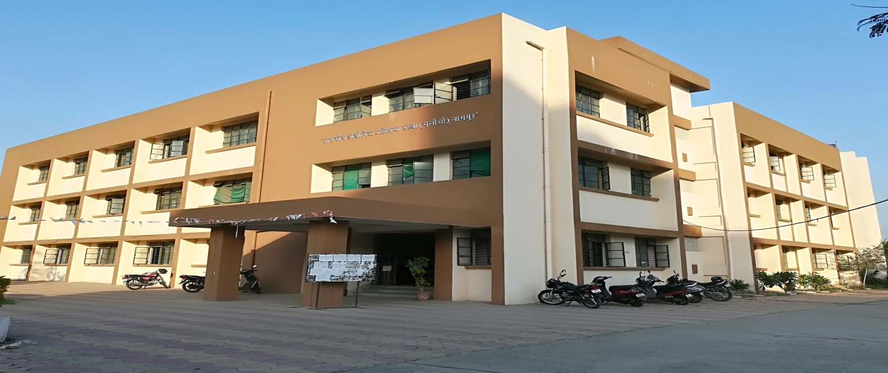

**ADMINISTRATIVE BUILDING**

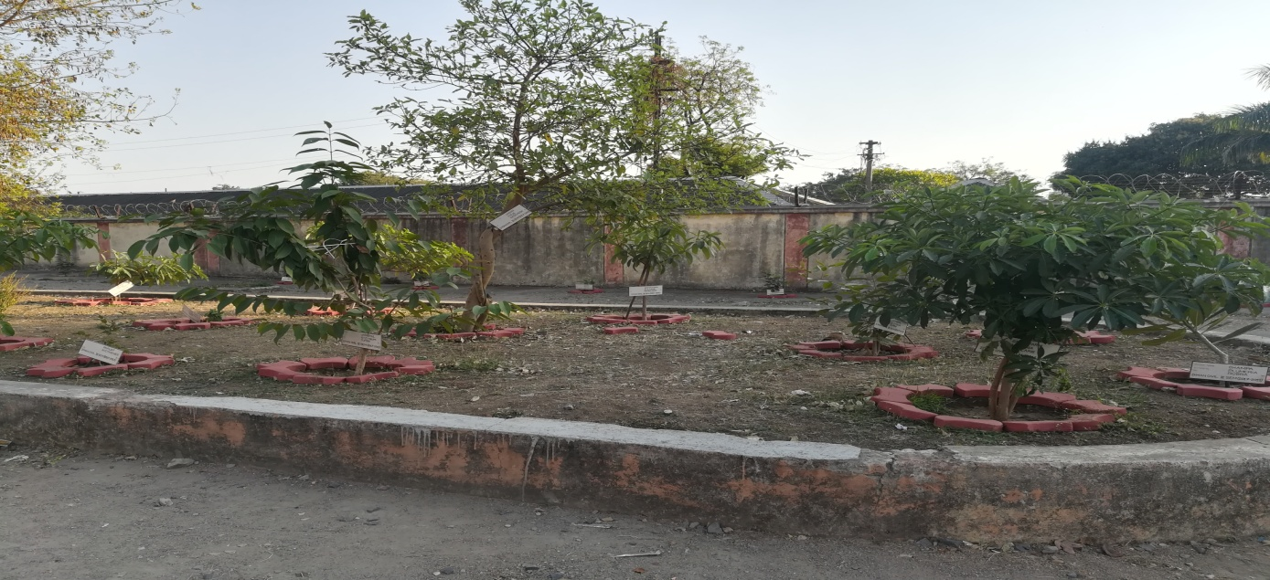

**GARDEN AREA**

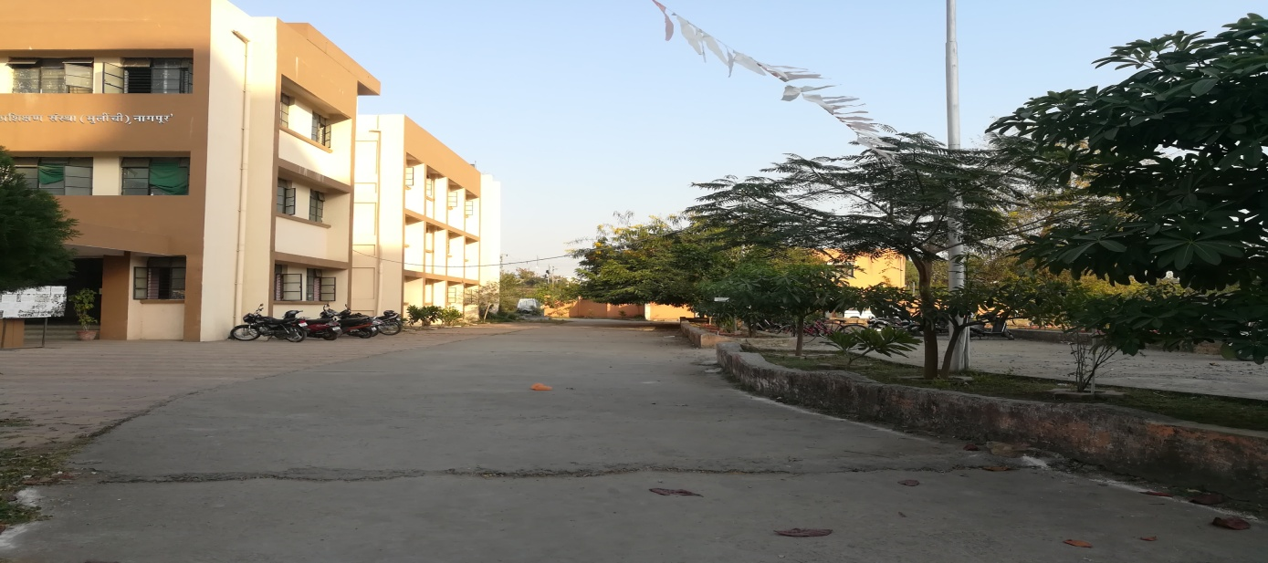

**GARDEN AREA**

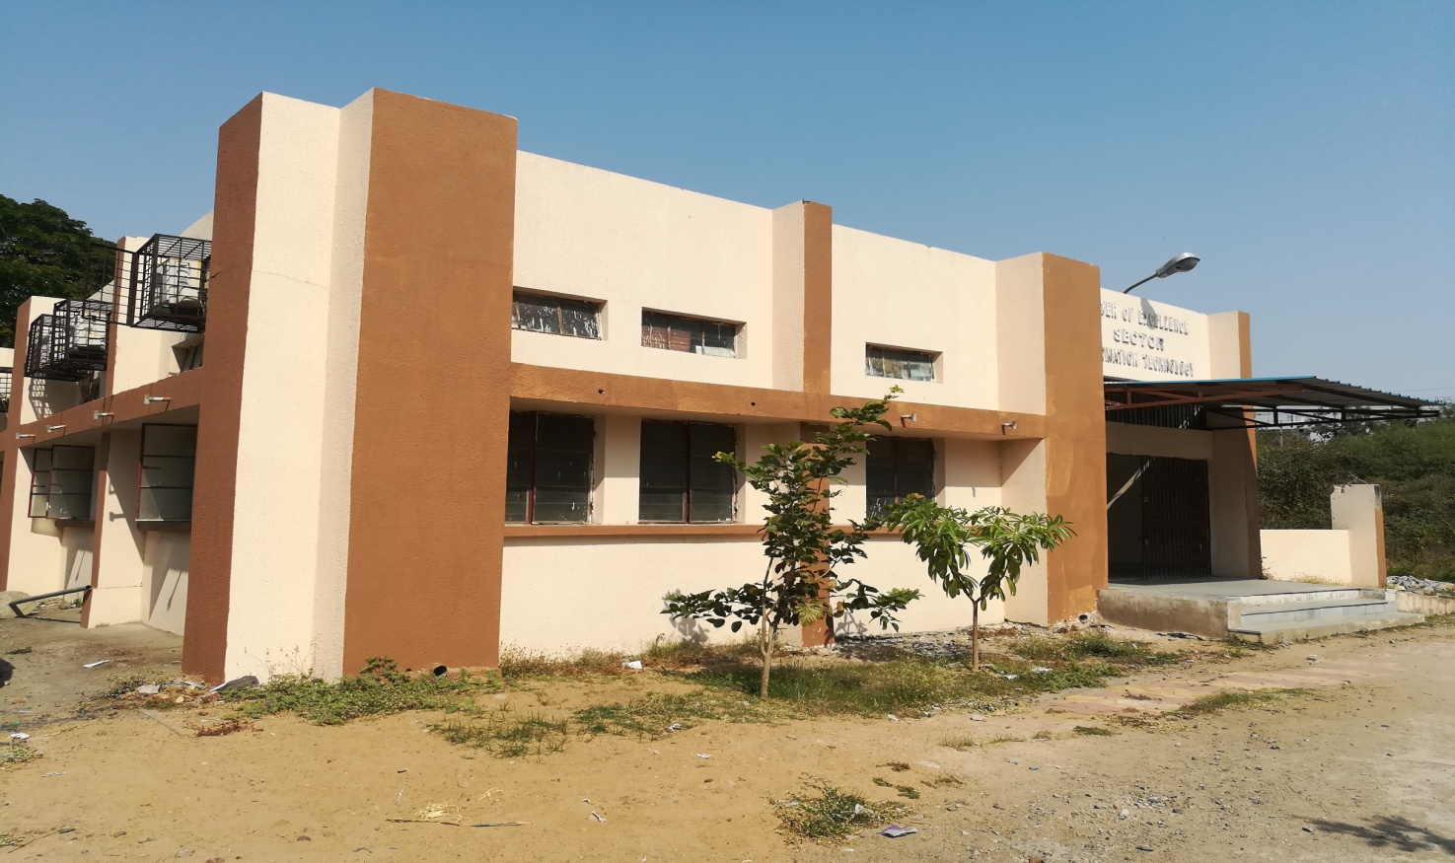

**COE BUILDING**

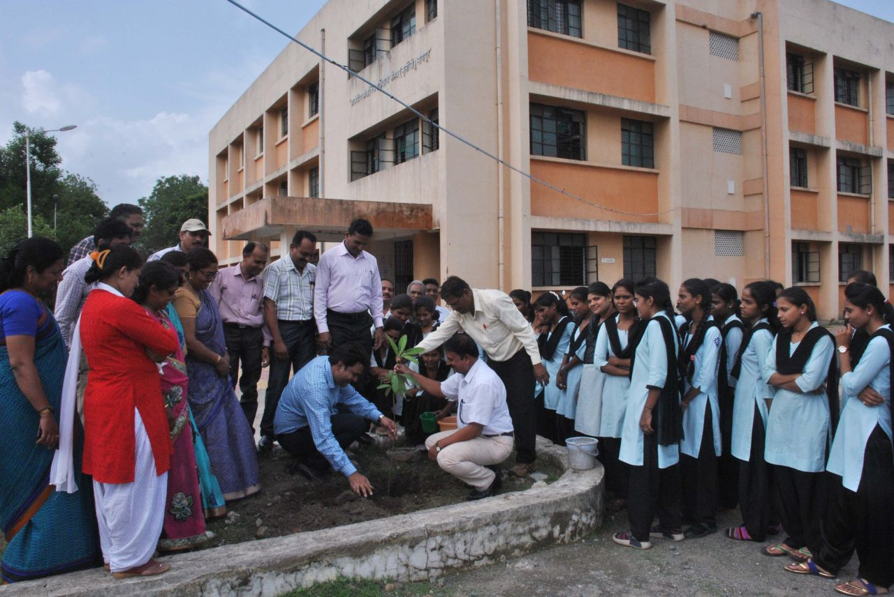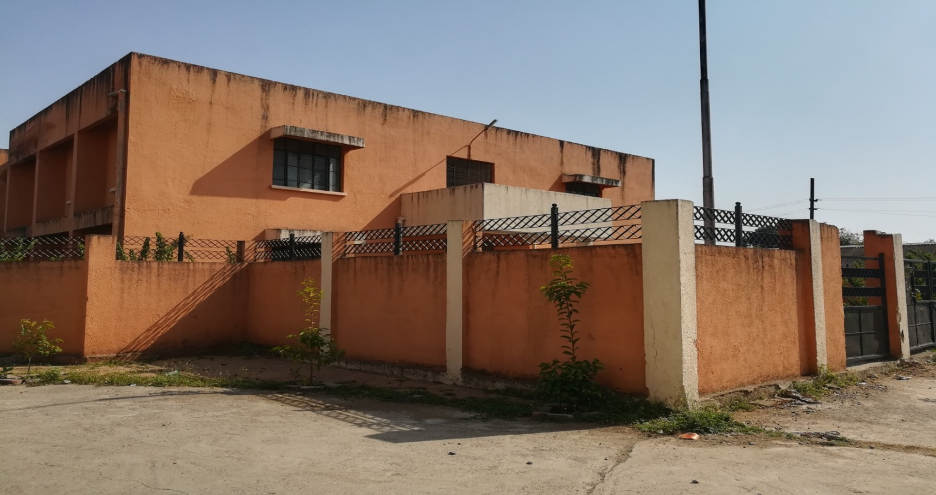

**HOSTEL BUILDING**

**TREE PLANTATION PROGRAM**

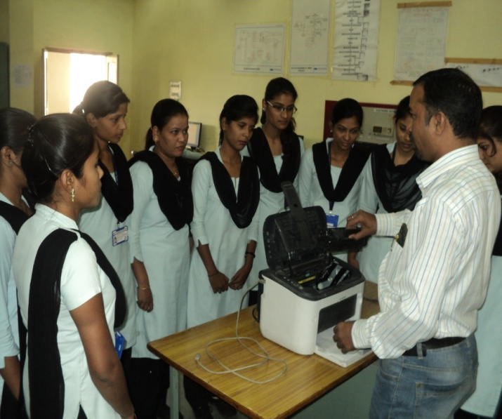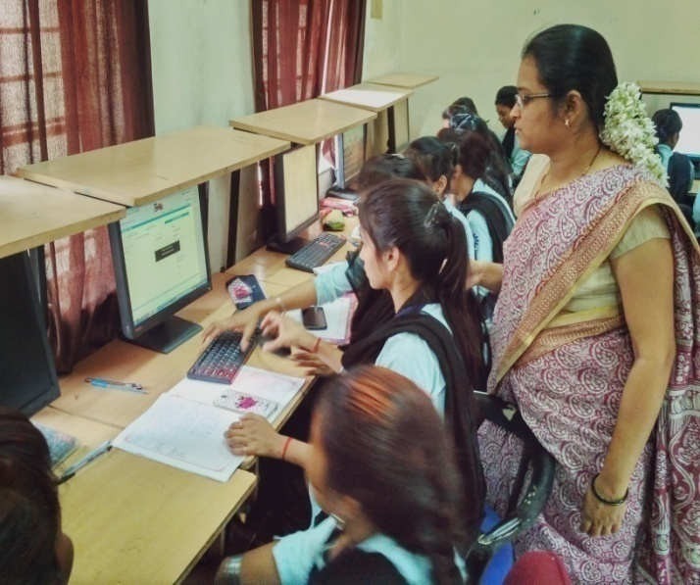

**Computer Operator & Programming Assistant**

**Computer Hardware & Network Maintaince**

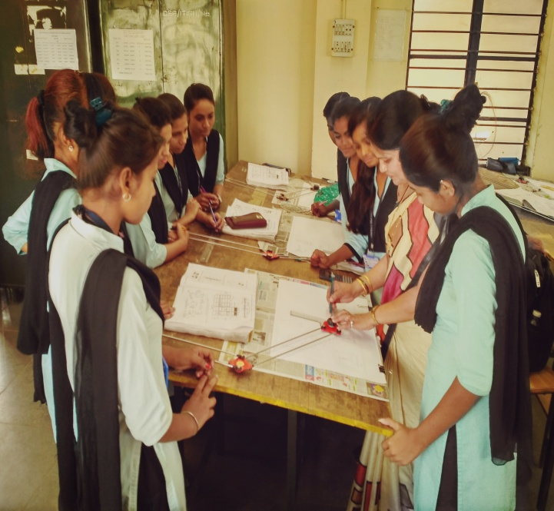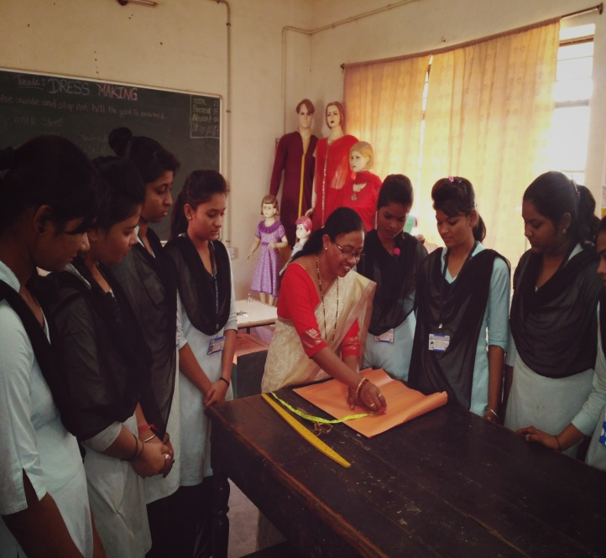

**Dress Making**

**Draughtsman Civil**

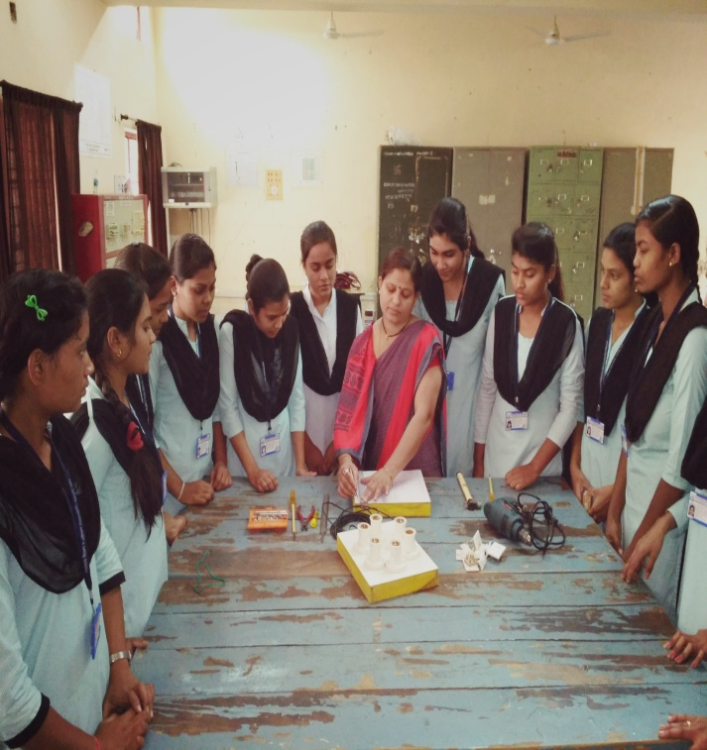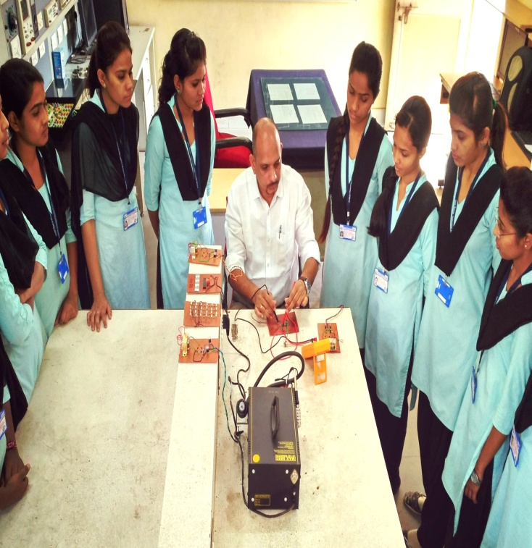

**Electronic Mechanic**

**Electrician**

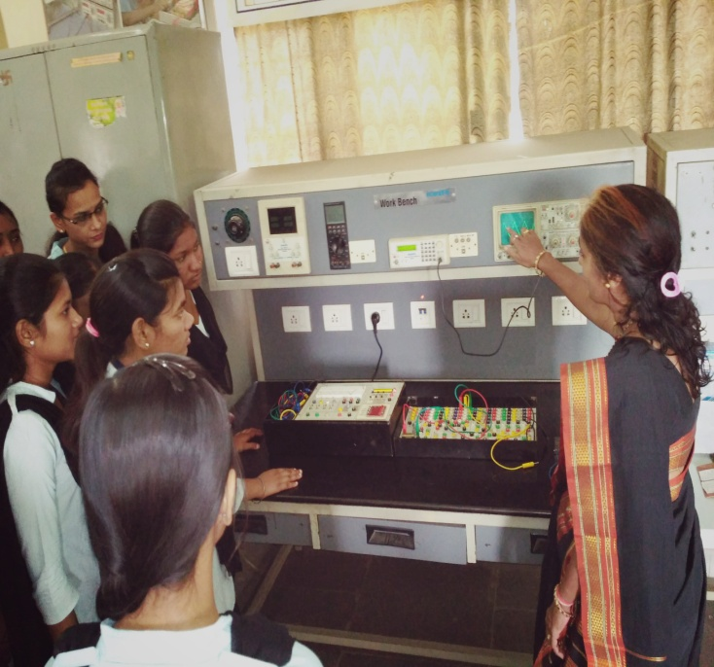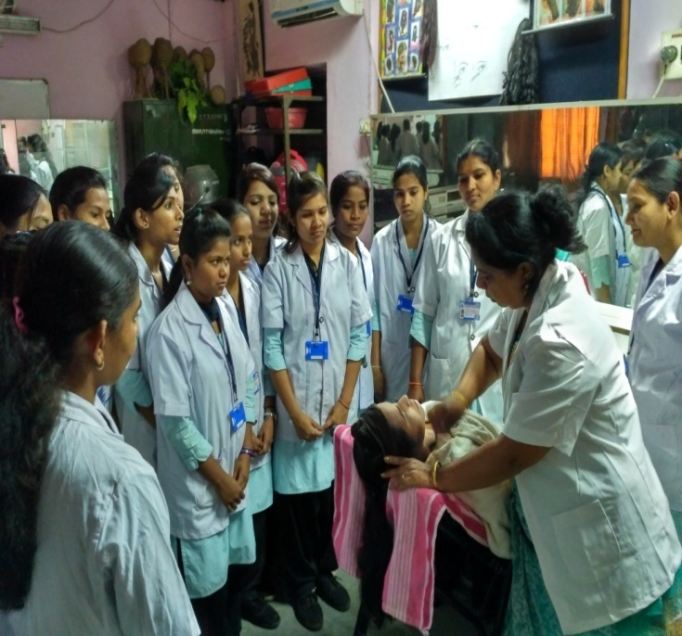

**Basic Cosmetology**

**Electronic Mechanic**

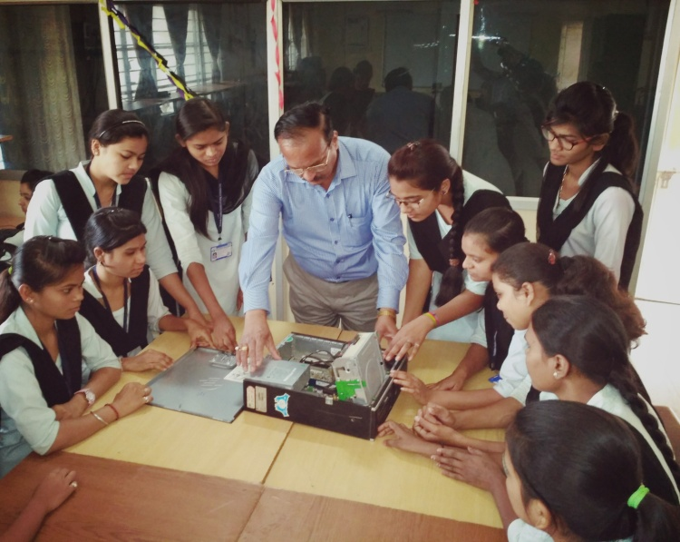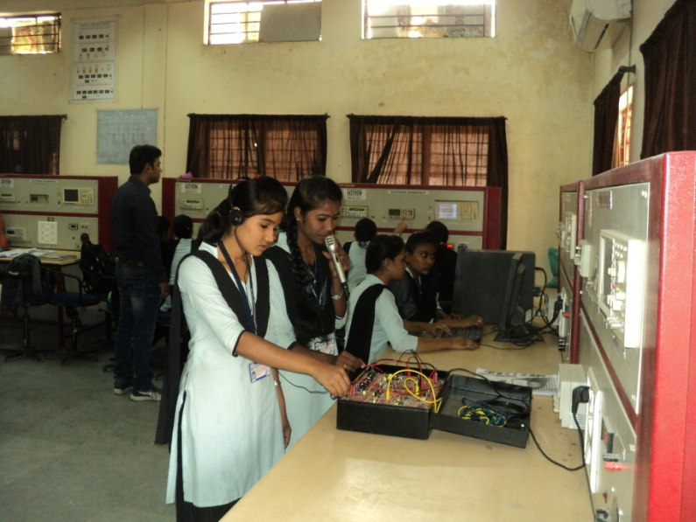

**Mech. Consumer Electronics Appliances**

**ICTSM**

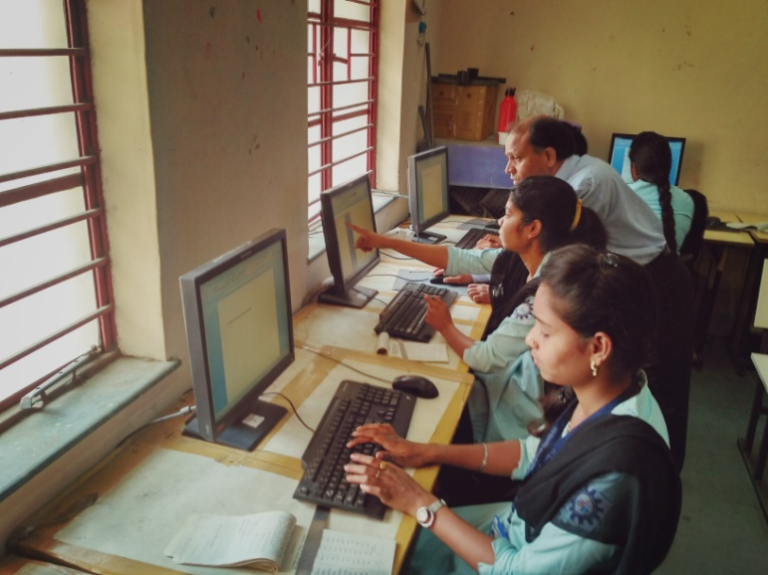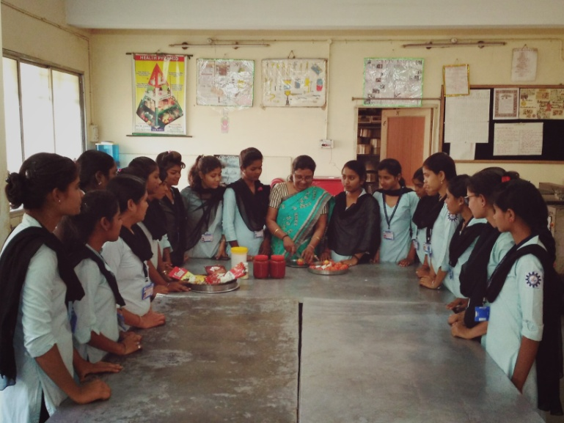

**Secretarial Practice (English)**

**Fruit & Vegetable Processing**

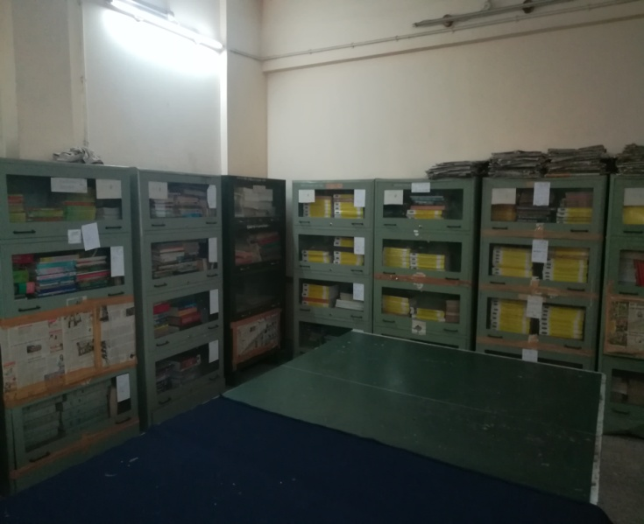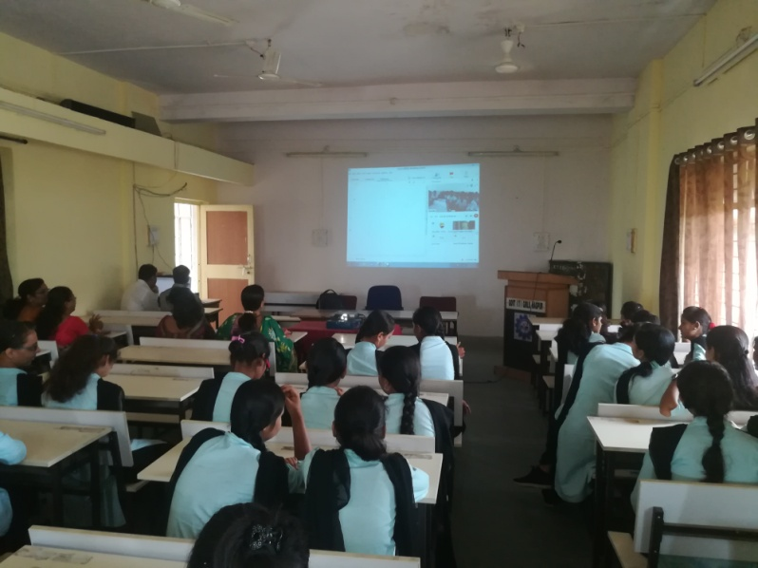

**Library**

**AVA Hall for Webinar & Other Activity**

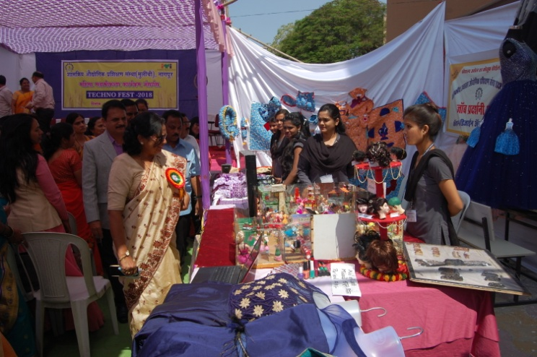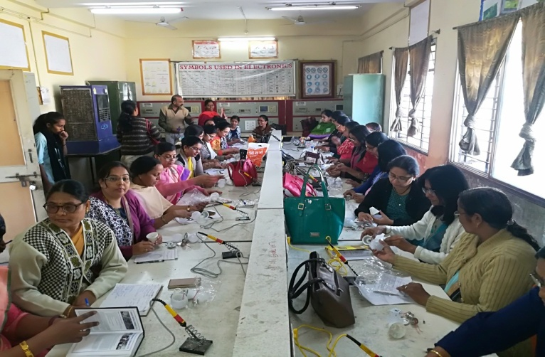

**LED Bulb Manufacturing Training**

**Techno Fest at ITI for Non-Engg. Trades**

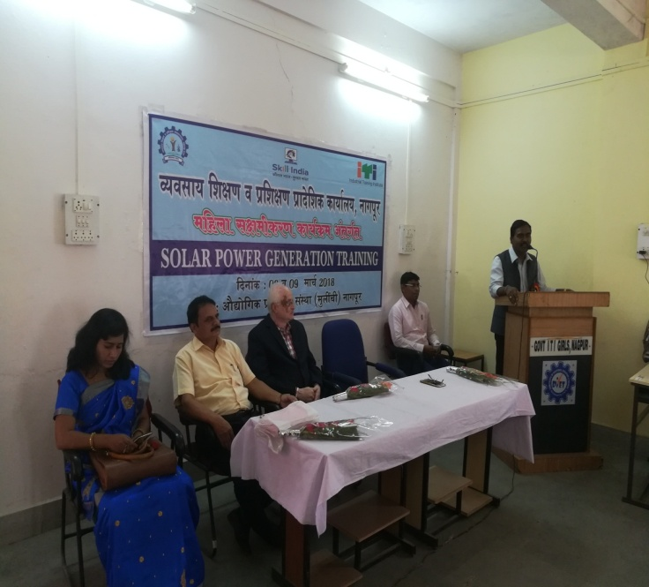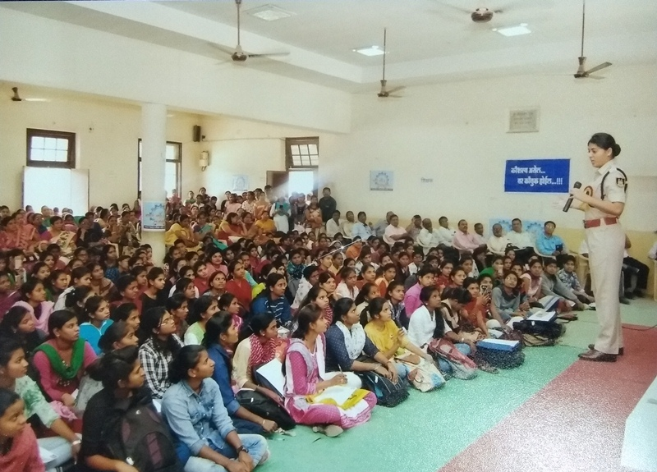

**Women Empowerment Programs**

**Solar Power Generation Training**

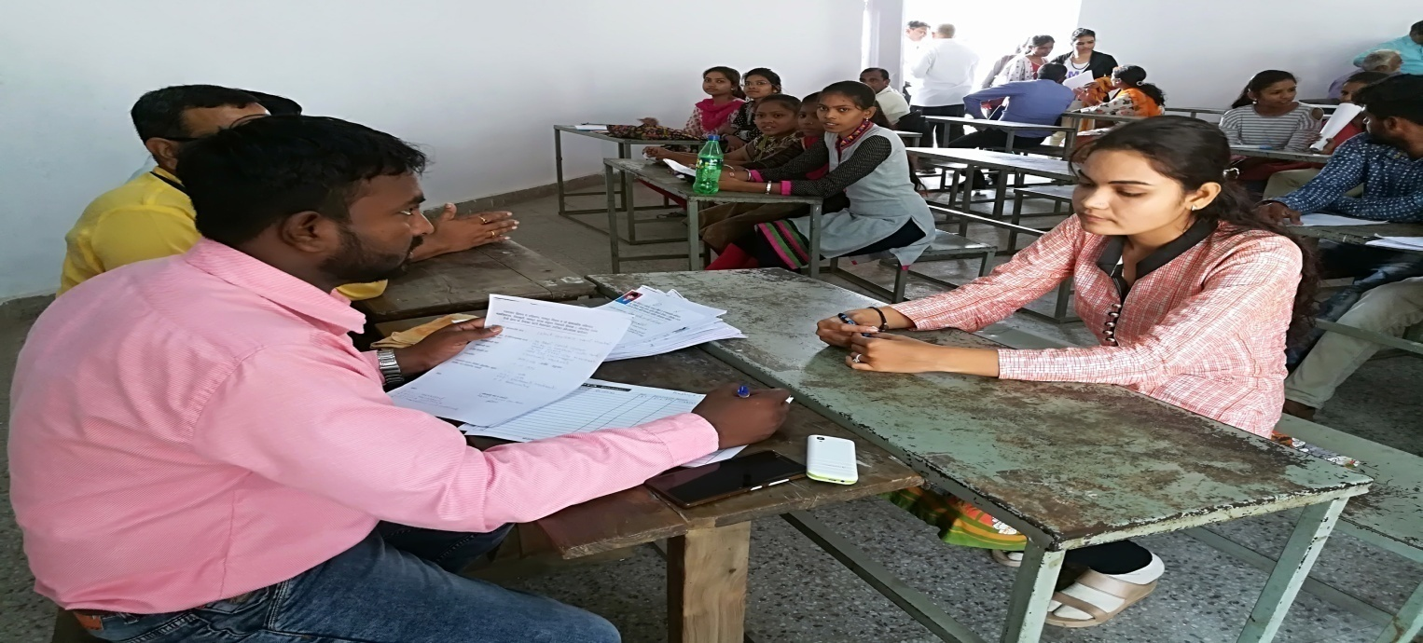

**Campus Recruitment for Trainees**